# VISVESVARAYA TECHNOLOGICAL UNIVERSITY

**“JnanaSangama”, Belgaum -590014, Karnataka.**



## LAB REPORT

### on

Machine Learning (23CS6PCMAL)

#### Submitted by

**Keerthana S (1BM22CS127)**

#### in partial fulfillment for the award of the degree of

**BACHELOR OF ENGINEERING**

***in***

## COMPUTER SCIENCE AND ENGINEERING



**B.M.S. COLLEGE OF ENGINEERING**

**(Autonomous Institution under VTU)**

## BENGALURU-560019

### Sep-2024 to Jan-2025

**B.M.S. College of Engineering,**

**Bull Temple Road, Bangalore 560019**

(Affiliated To Visvesvaraya Technological University, Belgaum)

**Department of Computer Science and Engineering**



##### CERTIFICATE

This is to certify that the Lab work entitled “Machine Learning (23CS6PCMAL)” carried out by **Keerthana S (1BM22CS127),** who is bonafide student of **B.M.S. College of Engineering.** It is in partial fulfillment for the award of **Bachelor of Engineering in Computer Science and Engineering** of the Visvesvaraya Technological University, Belgaum. The Lab report has been approved as it satisfies the academic requirements in respect of a Machine Learning (23CS6PCMAL) work prescribed for the said degree.

Dr. Kavitha Sooda Professor & HOD

Department of CSE, BMSCE

Srushti C S

Assistant Professor Department of CSE, BMSCE

# Index

|  |  |  |  |
| --- | --- | --- | --- |
| **Sl.**  **No.** | **Date** | **Experiment Title** | **Page No.** |
| 1 | 4-3-2025 | Write a python program to import and export data using Pandas library functions | 1 |
| 2 | 11-3-2025 | Demonstrate various data pre-processing techniques for a given dataset | 5 |
| 3 | 18-3-2025 | Use an appropriate data set for building the decision tree (ID3) and apply this knowledge to classify a new sample | 10 |
| 4 | 1-4-2025 | Implement Linear and Multi-Linear Regression algorithm using appropriate dataset | 17 |
| 5 | 8-4-2025 | Build Logistic Regression Model for a given dataset | 26 |
| 6 | 15-4-2025 | Build KNN Classification model for a given dataset | 31 |
| 7 | 15-4-2025 | Build Support vector machine model for a given dataset | 36 |
| 8 | 22-4-2025 | Implement Random forest ensemble method on a given dataset | 41 |
| 9 | 22-4-2025 | Implement Boosting ensemble method on a given dataset | 43 |
| 10 | 29-4-2025 | Build k-Means algorithm to cluster a set of data stored in a .CSV file | 46 |
| 11 | 29-4-2025 | Implement Dimensionality reduction using Principal Component Analysis (PCA) method | 49 |

Github Link:

<https://github.com/KeerthanaS-2004/6thSem-ML-Lab>

##### Program 1

Write a python program to import and export data using Pandas library functions

**Screenshot**

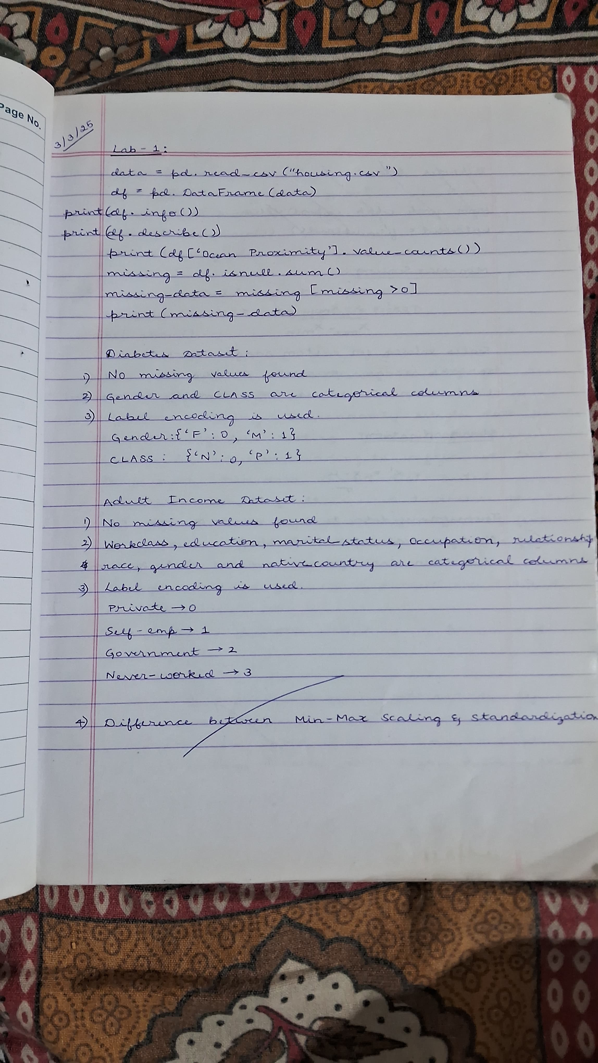

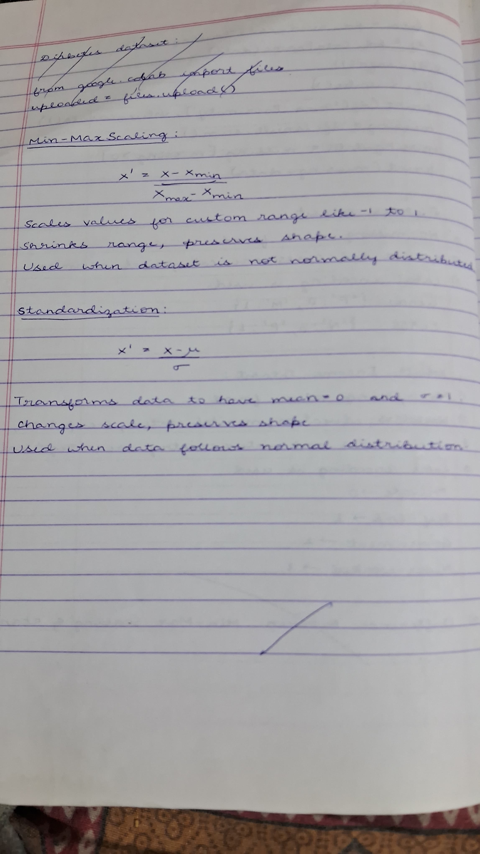

**Code:**

import pandas as pd

import numpy as np

import matplotlib.pyplot as plt

from sklearn.model_selection import train_test_split

from sklearn.impute import SimpleImputer

from sklearn.preprocessing import OrdinalEncoder, OneHotEncoder

from sklearn.preprocessing import StandardScaler, MinMaxScaler

from scipy import stats

def createdata():

  data = {

      'Age': np.random.randint(18, 70, size=20),

      'Salary': np.random.randint(30000, 120000, size=20),

      'Purchased': np.random.choice([0, 1], size=20),

      'Gender': np.random.choice(['Male', 'Female'], size=20),

      'City': np.random.choice(['New York', 'San Francisco', 'Los Angeles'], size=20)

  }

df = pd.DataFrame(data)

df = createdata()

df.loc[5, 'Age'] = np.nan

df.loc[10, 'Salary'] = np.nan

missing_values = df.isnull().sum()

print(missing_values[missing_values > 0])

imputer1 = SimpleImputer(strategy="median")

imputer2 = SimpleImputer(strategy="mean")

df_copy=df

imputer1.fit(df_copy[["Age"]])

imputer2.fit(df_copy[["Salary"]])

df_copy["Age"] = imputer1.transform(df[["Age"]])

df_copy["Salary"] = imputer2.transform(df[["Salary"]])

print(df_copy["Age"].isnull().sum())

print(df_copy["Salary"].isnull().sum())

#Handling Categorical Attributes

#Using Ordinal Encoding for gender Column and One-Hot Encoding for City Column

ordinal_encoder = OrdinalEncoder(categories=[["Male", "Female"]])

df_copy["Gender_Encoded"] = ordinal_encoder.fit_transform(df_copy[["Gender"]])

onehot_encoder = OneHotEncoder()

encoded_data = onehot_encoder.fit_transform(df[["City"]])

encoded_array = encoded_data.toarray()

encoded_df = pd.DataFrame(encoded_array, columns=onehot_encoder.get_feature_names_out(["City"]))

df_encoded = pd.concat([df_copy, encoded_df], axis=1)

df_encoded.drop("Gender", axis=1, inplace=True)

df_encoded.drop("City", axis=1, inplace=True)

print(df_encoded. head())

#Data Transformation

# Min-Max Scaler/Normalization (range 0-1)

normalizer = MinMaxScaler()

df_encoded[['Salary']] = normalizer.fit_transform(df_encoded[['Salary']])

df_encoded.head()

scaler = StandardScaler()

df_encoded[['Age']] = scaler.fit_transform(df_encoded[['Age']])

df_encoded.head()

#Removing Outliers with  Outlier Detection and Treatment using IQR

df_encoded_copy1=df_encoded

df_encoded_copy2=df_encoded

df_encoded_copy3=df_encoded

Q1 = df_encoded_copy1['Salary'].quantile(0.25)

Q3 = df_encoded_copy1['Salary'].quantile(0.75)

IQR = Q3 - Q1

lower_bound = Q1 - 1.5 * IQR

upper_bound = Q3 + 1.5 * IQR

df_encoded_copy1['Salary'] = np.where(df_encoded_copy1['Salary'] > upper_bound, upper_bound,

                        np.where(df_encoded_copy1['Salary'] < lower_bound, lower_bound, df_encoded_copy1['Salary']))

print(df_encoded_copy1.head())

#Removing Outliers with Z-score

df_encoded_copy2['Salary_zscore'] = stats.zscore(df_encoded_copy2['Salary'])

df_encoded_copy2['Salary'] = np.where(df_encoded_copy2['Salary_zscore'].abs() > 3, np.nan, df_encoded_copy2['Salary'])  # Replace outliers with NaN

print(df_encoded_copy2.head())

#Removing Outliers with Median replacement for outliers

df_encoded_copy3['Salary_zscore'] = stats.zscore(df_encoded_copy3['Salary'])

median_salary = df_encoded_copy3['Salary'].median()

df_encoded_copy3['Salary'] = np.where(df_encoded_copy3['Salary_zscore'].abs() > 3, median_salary, df_encoded_copy3['Salary'])

print(df_encoded_copy3.head())

##### Program 2

Demonstrate various data pre-processing techniques for a given dataset

**Screenshot**

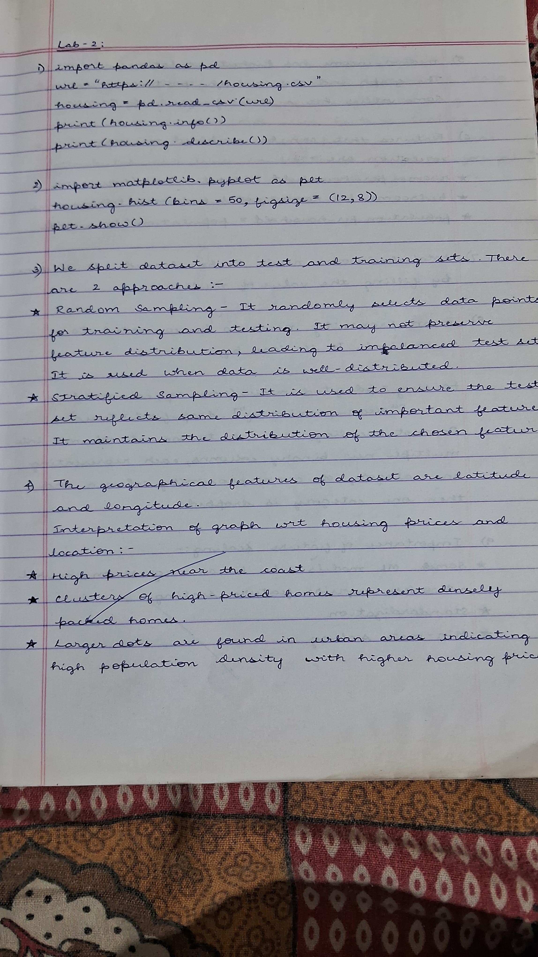

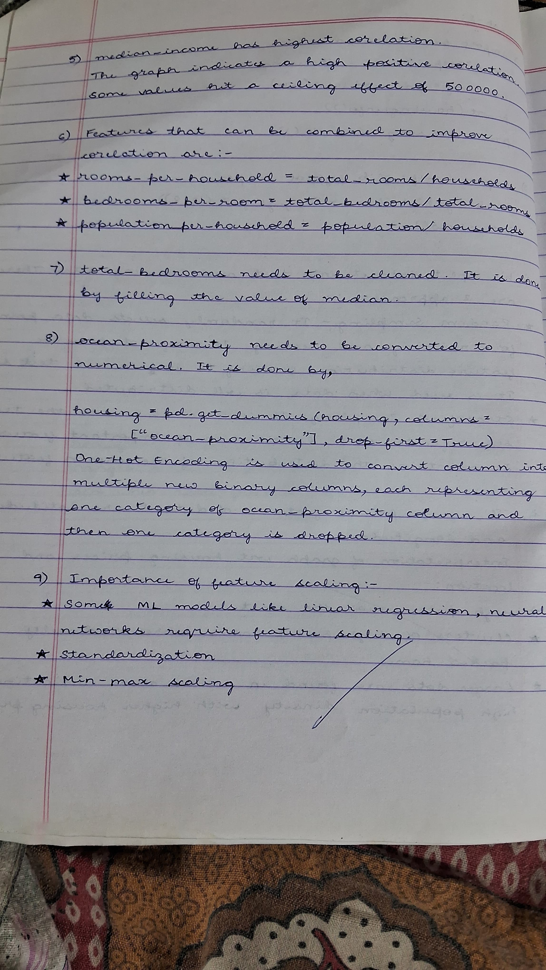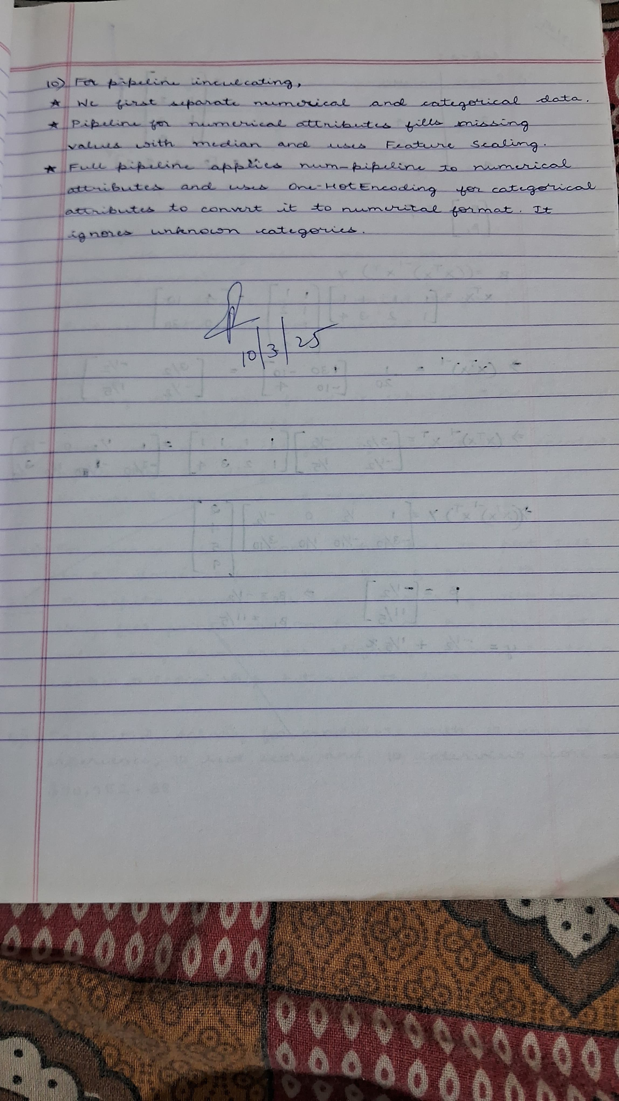

**Code:**

import pandas as pd

url = "https://media.geeksforgeeks.org/wp-content/uploads/20240319120216/housing.csv"

housing = pd.read_csv(url)

print(housing.info())

print(housing.describe())

print(housing.head())

import matplotlib.pyplot as plt

housing.hist(bins=50, figsize=(12, 8))

plt.show()

#creating test set

from sklearn.model_selection import train_test_split

import numpy as np

# Random Sampling

train_set, test_set = train_test_split(housing, test_size=0.2, random_state=42)

# Stratified Sampling by median_income

housing["income_cat"] = pd.cut(housing["median_income"],

                               bins=[0., 1.5, 3.0, 4.5, 6., np.inf],

                               labels=[1, 2, 3, 4, 5])

from sklearn.model_selection import StratifiedShuffleSplit

split = StratifiedShuffleSplit(n_splits=1, test_size=0.2, random_state=42)

for train_index, test_index in split.split(housing, housing["income_cat"]):

    strat_train_set = housing.loc[train_index]

    strat_test_set = housing.loc[test_index]

#geographical features visualization

housing.plot(kind="scatter", x="longitude", y="latitude", alpha=0.4,

             s=housing["population"]/100, label="population",

             c="median_house_value", cmap=plt.get_cmap("jet"),

             colorbar=True, figsize=(10,7))

plt.legend()

plt.show()

#feature corelation with housing prices

corr_matrix = housing.select_dtypes(include=[np.number]).corr()

print(corr_matrix["median_house_value"].sort_values(ascending=False))

housing_encoded = pd.get_dummies(housing, drop_first=True)  # Convert categorical to numerical

corr_matrix = housing_encoded.corr()

print(corr_matrix["median_house_value"].sort_values(ascending=False))

#visualizing median_income vs median_house_value

housing.plot(kind="scatter", x="median_income", y="median_house_value", alpha=0.3)

plt.show()

#feature engineering-combining features

housing["rooms_per_household"] = housing["total_rooms"] / housing["households"]

housing["bedrooms_per_room"] = housing["total_bedrooms"] / housing["total_rooms"]

corr_matrix = housing.select_dtypes(include=[np.number]).corr()

print(corr_matrix["median_house_value"].sort_values(ascending=False))

housing_encoded = pd.get_dummies(housing, drop_first=True)  # Convert categorical to numerical

corr_matrix = housing_encoded.corr()

print(corr_matrix["median_house_value"].sort_values(ascending=False))

#data cleaning

housing.dropna(subset=["total_bedrooms"], inplace=True)

housing["total_bedrooms"].fillna(housing["total_bedrooms"].median(), inplace=True)

housing = pd.get_dummies(housing, columns=["ocean_proximity"], drop_first=True)

#creating machine learning pipeline

from sklearn.pipeline import Pipeline

from sklearn.preprocessing import StandardScaler, OneHotEncoder

from sklearn.impute import SimpleImputer

from sklearn.compose import ColumnTransformer

# Separating numerical and categorical attributes

num_attribs = housing.drop("median_house_value", axis=1).select_dtypes(include=[np.number]).columns

cat_attribs = ["ocean_proximity"]

# Pipeline for numerical attributes

num_pipeline = Pipeline([

    ("imputer", SimpleImputer(strategy="median")),

    ("scaler", StandardScaler())

])

# Full pipeline

full_pipeline = ColumnTransformer([

    ("num", num_pipeline, num_attribs),

    ("cat", OneHotEncoder(handle_unknown="ignore"), cat_attribs)

])

# Applying the pipeline

housing_prepared = full_pipeline.fit_transform(housing)

#mode selection and training

from sklearn.ensemble import RandomForestRegressor

from sklearn.metrics import mean_absolute_error

# Train Model

model = RandomForestRegressor(n_estimators=100, random_state=42)

model.fit(housing_prepared, housing["median_house_value"])

predictions = model.predict(housing_prepared)

mae = mean_absolute_error(housing["median_house_value"], predictions)

print("Mean Absolute Error:", mae)

##### Program 3

Use an appropriate data set for building the decision tree (ID3) and apply this knowledge to classify a new sample.

**Screenshot**

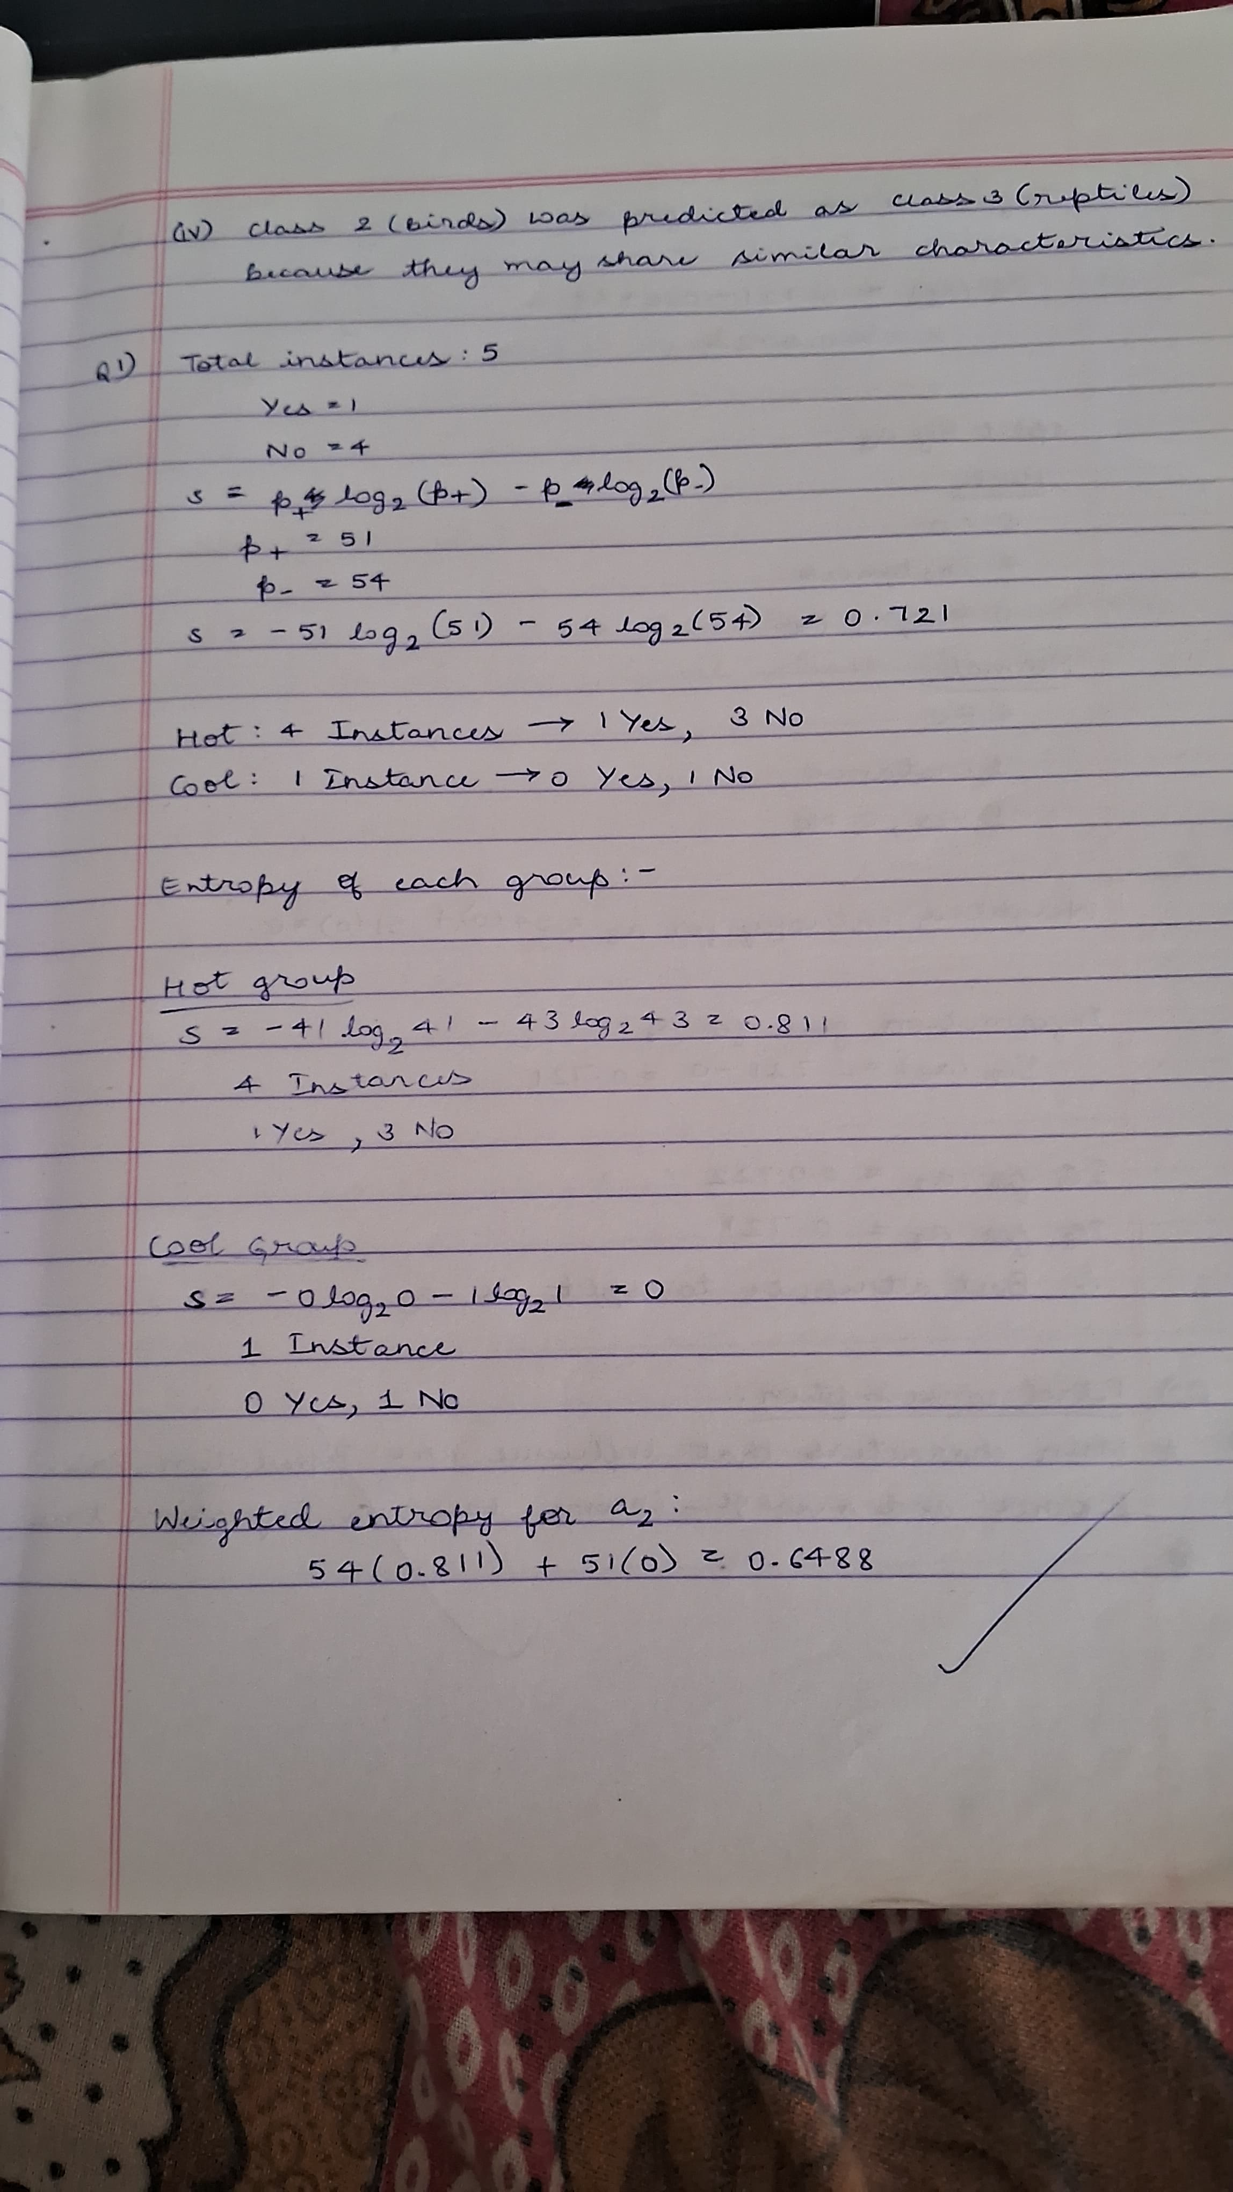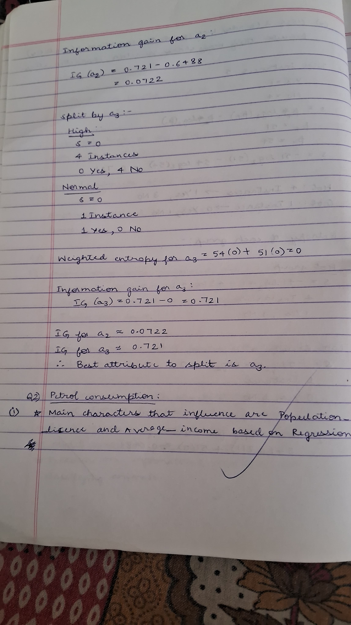



**Code:**

#decision_tree

import pandas as pd

from sklearn.preprocessing import LabelEncoder

from sklearn.tree import DecisionTreeClassifier

from sklearn.model_selection import train_test_split

from sklearn.metrics import accuracy_score, classification_report

# Create the dataset

data = {

    'a1': [True, True, False, False, False, True, True, True, False, False],

    'a2': ['Hot', 'Hot', 'Hot', 'Cool', 'Cool', 'Cool', 'Hot', 'Hot', 'Cool', 'Cool'],

    'a3': ['High', 'High', 'High', 'Normal', 'Normal', 'High', 'High', 'Normal', 'Normal', 'High'],

    'Classification': ['No', 'No', 'Yes', 'Yes', 'Yes', 'No', 'No', 'Yes', 'Yes', 'Yes']

}

data

df = pd.DataFrame(data)

label_encoders = {}

for column in df.columns:

    le = LabelEncoder()

    df[column] = le.fit_transform(df[column])

    label_encoders[column] = le

# Split the dataset into features and target

X = df.drop('Classification', axis=1)

y = df['Classification']

# Split the data into training and testing sets

X_train, X_test, y_train, y_test = train_test_split(X, y, test_size=0.3, random_state=42)

# Initialize the Decision Tree Classifier with entropy as the criterion

clf = DecisionTreeClassifier(criterion='entropy')

# Train the classifier

clf.fit(X_train, y_train)

# Make predictions

y_pred = clf.predict(X_test)

# Evaluate the classifier

accuracy = accuracy_score(y_test, y_pred)

print(f'Accuracy: {accuracy:.2f}')

print(classification_report(y_test, y_pred, target_names=['No', 'Yes']))

# Optionally, visualize the decision tree

from sklearn.tree import plot_tree

import matplotlib.pyplot as plt

plt.figure(figsize=(12,8))

plot_tree(clf, filled=True, feature_names=X.columns, class_names=['No', 'Yes'])

plt.show()

**Iris_dataset**

import pandas as pd

from sklearn.model_selection import train_test_split

from sklearn.tree import DecisionTreeClassifier

from sklearn.metrics import accuracy_score, confusion_matrix

import seaborn as sns

import matplotlib.pyplot as plt

from google.colab import files

# Upload the dataset

print("Please upload 'iris.csv'")

uploaded = files.upload()

df = pd.read_csv(next(iter(uploaded)))

print("\nDataset Preview:")

print(df.head())

# Define features (X) and target (y)

X = df.drop('species', axis=1)

y = df['species']

# Split into train (80%) and test (20%)

X_train, X_test, y_train, y_test = train_test_split(X, y, test_size=0.2, random_state=42)

# Build and train the Decision Tree classifier

model = DecisionTreeClassifier(random_state=42)

model.fit(X_train, y_train)

# Predict on test data

y_pred = model.predict(X_test)

# Calculate accuracy

accuracy = accuracy_score(y_test, y_pred)

print(f"\nAccuracy Score: {accuracy:.2f}")

# Display confusion matrix

cm = confusion_matrix(y_test, y_pred)

# Plot the confusion matrix

plt.figure(figsize=(6, 5))

sns.heatmap(cm, annot=True, fmt='d', cmap='Blues', xticklabels=model.classes_, yticklabels=model.classes_)

plt.title('Confusion Matrix - Iris Flower Classification')

plt.xlabel('Predicted')

plt.ylabel('Actual')

plt.tight_layout()

plt.show()

**Drug_dataset**

import pandas as pd

from sklearn.model_selection import train_test_split

from sklearn.tree import DecisionTreeClassifier

from sklearn.metrics import accuracy_score, confusion_matrix

import seaborn as sns

import matplotlib.pyplot as plt

from google.colab import files

# Upload the dataset

print("Please upload 'drug.csv'")

uploaded = files.upload()

df = pd.read_csv(next(iter(uploaded)))

print("\nDataset Preview:")

print(df.head())

# Preprocess data if necessary (e.g., convert categorical variables to numerical)

# Convert categorical 'Sex', 'BP', and 'Cholesterol' columns to numerical using encoding

df['Sex'] = df['Sex'].map({'M': 0, 'F': 1})  # Male = 0, Female = 1

df['BP'] = df['BP'].map({'LOW': 0, 'NORMAL': 1, 'HIGH': 2})  # Encoding BP levels

df['Cholesterol'] = df['Cholesterol'].map({'NORMAL': 0, 'HIGH': 1})  # Encoding Cholesterol levels

# Define features (X) and target (y)

X = df.drop('Drug', axis=1)

y = df['Drug']

# Split into train (80%) and test (20%)

X_train, X_test, y_train, y_test = train_test_split(X, y, test_size=0.2, random_state=42)

# Build and train the Decision Tree classifier

model = DecisionTreeClassifier(random_state=42)

model.fit(X_train, y_train)

# Predict on test data

y_pred = model.predict(X_test)

# Calculate accuracy

accuracy = accuracy_score(y_test, y_pred)

print(f"\nAccuracy Score: {accuracy:.2f}")

# Display confusion matrix

cm = confusion_matrix(y_test, y_pred)

plt.figure(figsize=(6, 5))

sns.heatmap(cm, annot=True, fmt='d', cmap='Blues', xticklabels=model.classes_, yticklabels=model.classes_)

plt.title('Confusion Matrix - Drug Classification')

plt.xlabel('Predicted')

plt.ylabel('Actual')

plt.tight_layout()

plt.show()

**Petrol_consumption**

import pandas as pd

import numpy as np

from sklearn.tree import DecisionTreeRegressor, plot_tree

from sklearn.model_selection import train_test_split

from sklearn.metrics import mean_absolute_error, mean_squared_error

import matplotlib.pyplot as plt

from google.colab import files

# Upload the dataset

print("Please upload 'petrol_consumption.csv'")

uploaded = files.upload()

df = pd.read_csv(next(iter(uploaded)))

print("\nDataset Preview:")

print(df.head())

# Define features (X) and target (y)

X = df.drop('Petrol_Consumption', axis=1)

y = df['Petrol_Consumption']

# Split into train (80%) and test (20%)

X_train, X_test, y_train, y_test = train_test_split(X, y, test_size=0.2, random_state=42)

# Build and train the regression tree model

model = DecisionTreeRegressor(random_state=42)

model.fit(X_train, y_train)

# Predict on test data

y_pred = model.predict(X_test)

# Calculate error metrics

mae = mean_absolute_error(y_test, y_pred)

mse = mean_squared_error(y_test, y_pred)

rmse = np.sqrt(mse)

# Display the error metrics

print(f"\n📊 Evaluation Metrics:")

print(f"Mean Absolute Error (MAE): {mae:.2f}")

print(f"Mean Squared Error (MSE): {mse:.2f}")

print(f"Root Mean Squared Error (RMSE): {rmse:.2f}")

# Visualize the regression tree

plt.figure(figsize=(20,10))

plot_tree(model, feature_names=X.columns, filled=True, rounded=True)

plt.title("Regression Tree for Petrol Consumption")

plt.show()

##### Program 4

Implement Linear and Multi-Linear Regression algorithm using appropriate dataset

**Screenshot**

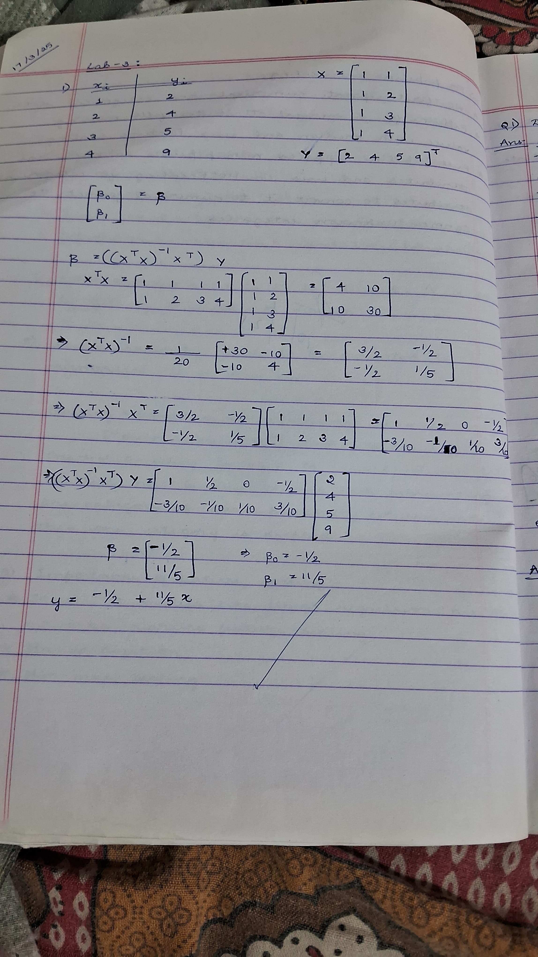

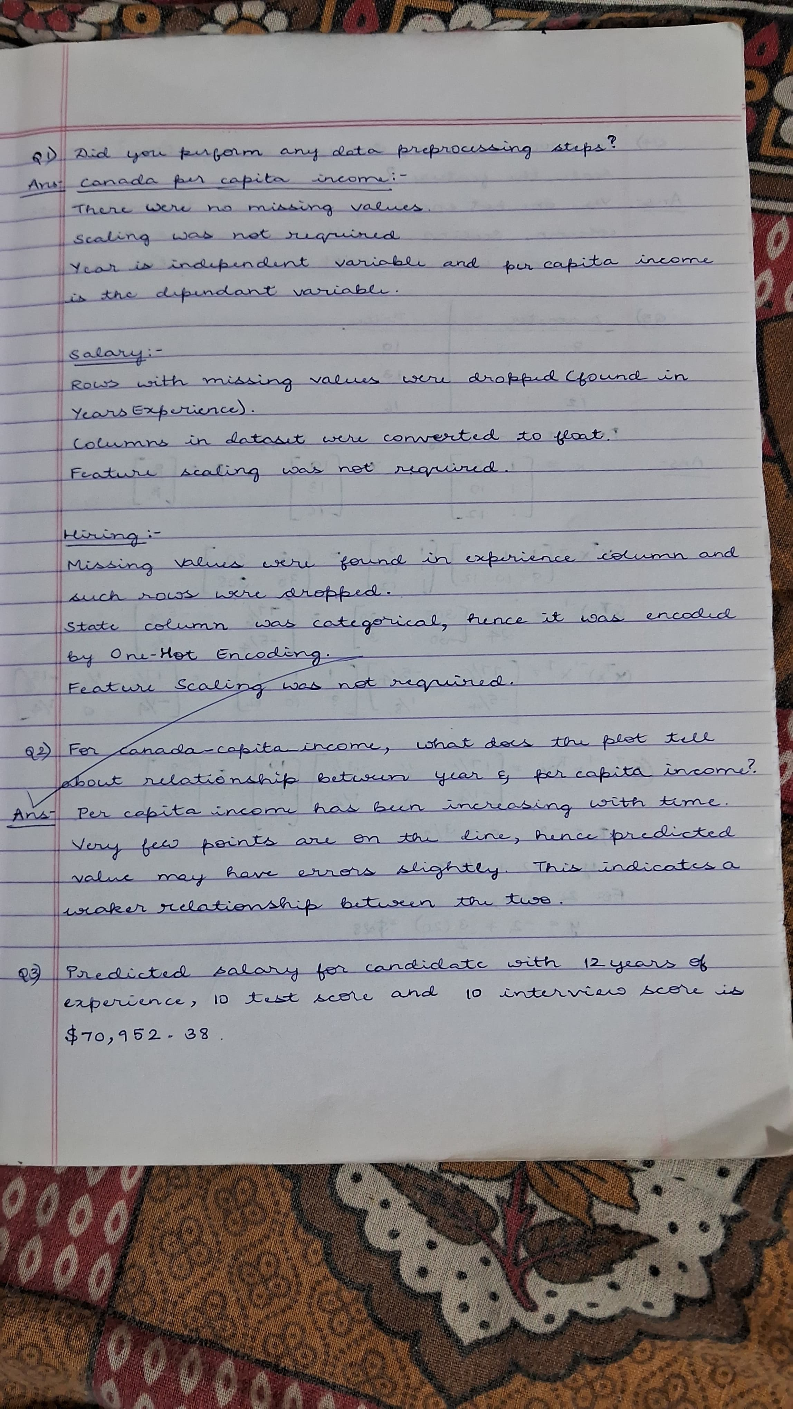

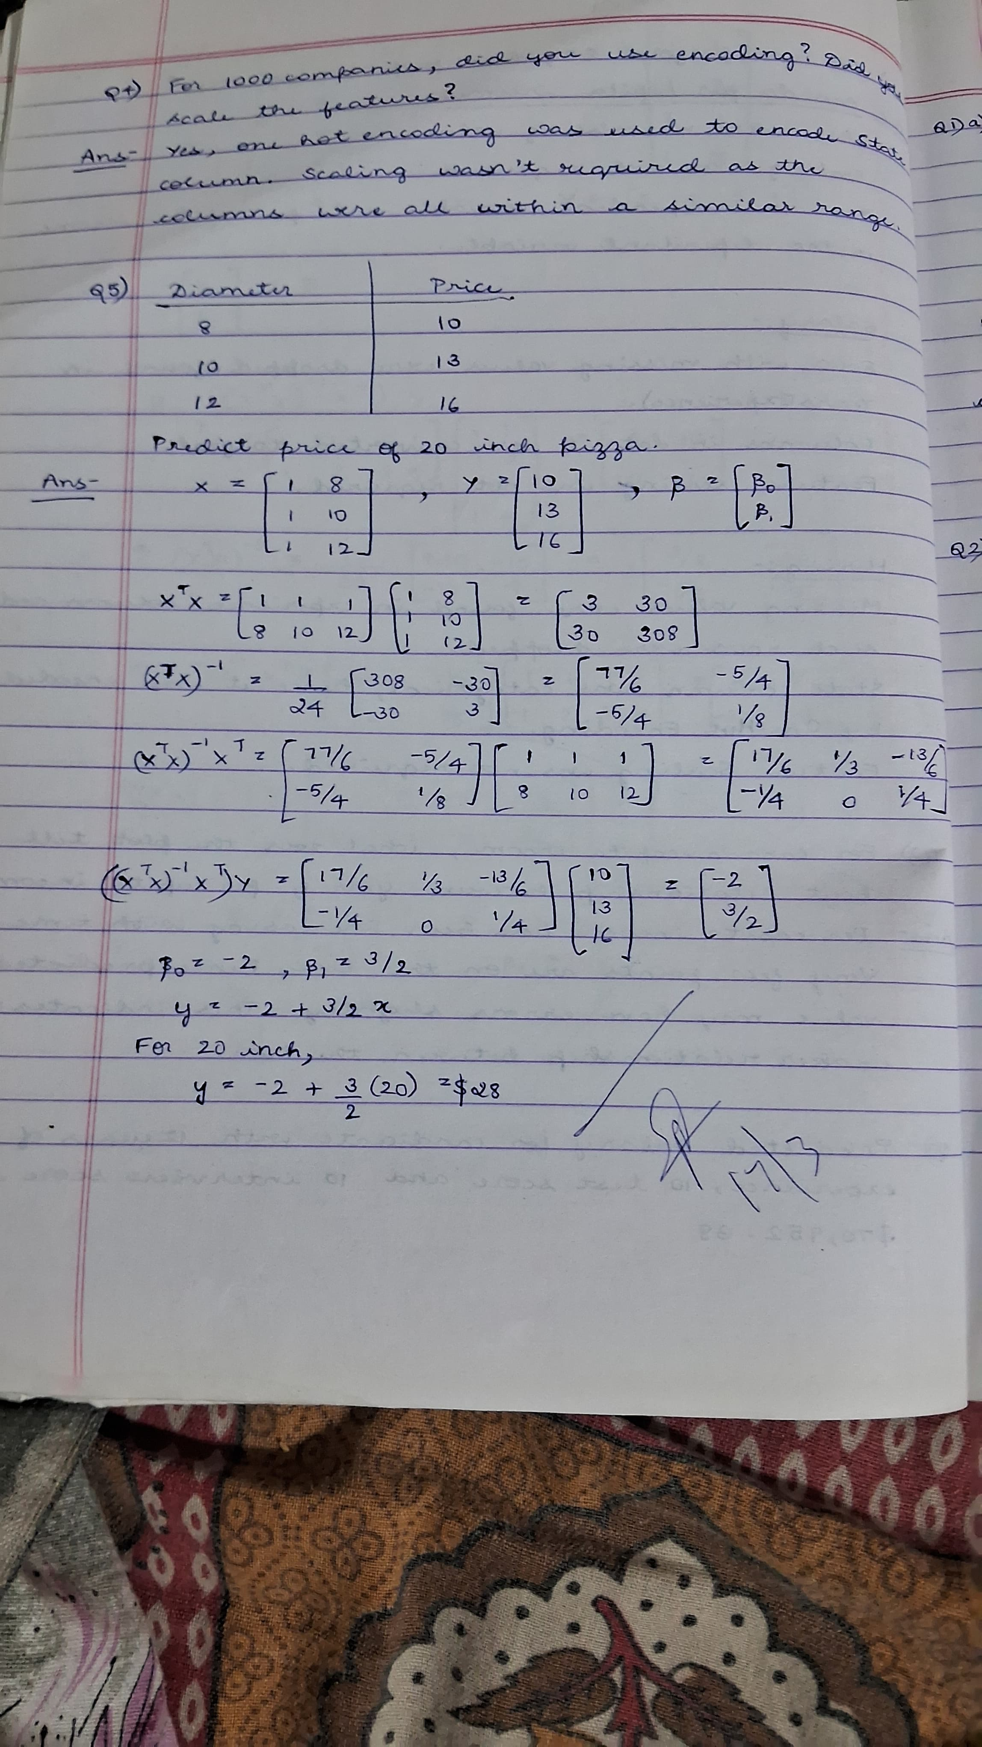

**Code:**

**Canada capital income dataset**

# Step 1: Import necessary libraries

import pandas as pd

import numpy as np

from sklearn.model_selection import train_test_split

from sklearn.linear_model import LinearRegression

from sklearn.metrics import mean_squared_error

import matplotlib.pyplot as plt

# Step 2: Upload the dataset

from google.colab import files

uploaded = files.upload()

data = pd.read_csv(next(iter(uploaded)))  # Load the first uploaded file

print(data.head())

# Step 3: Check the data for missing values or inconsistencies

print(data.info())

print(data.head())

# Step 4: Data preprocessing

# Ensure the columns are correctly typed, particularly ensuring 'Year' is numeric

data['year'] = pd.to_numeric(data['year'], errors='coerce')

data['per capita income (US$)'] = pd.to_numeric(data['per capita income (US$)'], errors='coerce')

data = data.dropna()

# Step 5: Visualize the data to understand the relationship

plt.scatter(data['year'], data['per capita income (US$)'], color='blue')

plt.xlabel('year')

plt.ylabel('per capita income (US$)')

plt.title('Canada Per Capita Income Over Years')

plt.show()

# Step 6: Prepare data for training

X = data['year'].values.reshape(-1, 1)

y = data['per capita income (US$)'].values

# Step 7: Split the data into training and testing sets

X_train, X_test, y_train, y_test = train_test_split(X, y, test_size=0.2, random_state=42)

# Step 8: Create and train the linear regression model

model = LinearRegression()

model.fit(X_train, y_train)

# Step 9: Evaluate the model (optional, just for understanding the accuracy)

y_pred = model.predict(X_test)

print(f"Mean Squared Error: {mean_squared_error(y_test, y_pred)}")

# Step 10: Predict per capita income for the year 2020

year_2020 = np.array([[2020]])

predicted_income_2020 = model.predict(year_2020)

print(f"Predicted per capita income in 2020: ${predicted_income_2020[0]:,.2f}")

# Step 11: Plot the regression line along with the data points

plt.scatter(X, y, color='blue')

plt.plot(X, model.predict(X), color='red', linewidth=2)

plt.xlabel('year')

plt.ylabel('per capita income (US$)')

plt.title('Linear Regression: Canada Per Capita Income Over Years')

plt.show()

**Salary dataset**

# Step 1: Import necessary libraries

import pandas as pd

import numpy as np

from sklearn.linear_model import LinearRegression

from sklearn.model_selection import train_test_split

from sklearn.metrics import mean_squared_error

import matplotlib.pyplot as plt

# Step 2: Load the dataset

from google.colab import files

uploaded = files.upload()

data = pd.read_csv(next(iter(uploaded)))

print(data.head())

# Step 3: Data preprocessing

print(data.info())

print(data.head())

# Ensure the columns are of numeric types (YearsExperience and Salary)

data['YearsExperience'] = pd.to_numeric(data['YearsExperience'], errors='coerce')

data['Salary'] = pd.to_numeric(data['Salary'], errors='coerce')

data = data.dropna()

# Step 4: Visualize the data

plt.scatter(data['YearsExperience'], data['Salary'], color='blue')

plt.xlabel('Years of Experience')

plt.ylabel('Salary')

plt.title('Salary vs Years of Experience')

plt.show()

# Step 5: Prepare the data for regression (Independent and Dependent variables)

X = data['YearsExperience'].values.reshape(-1, 1)  # Feature: YearsExperience

y = data['Salary'].values  # Target: Salary

# Step 6: Split the data into training and testing sets

X_train, X_test, y_train, y_test = train_test_split(X, y, test_size=0.2, random_state=42)

# Step 7: Create and train the linear regression model

model = LinearRegression()

model.fit(X_train, y_train)

# Step 8: Evaluate the model

y_pred = model.predict(X_test)

print(f"Mean Squared Error: {mean_squared_error(y_test, y_pred)}")

# Step 9: Predict the salary for an employee with 12 years of experience

years_of_experience = np.array([[12]])

predicted_salary = model.predict(years_of_experience)

print(f"Predicted salary for an employee with 12 years of experience: ${predicted_salary[0]:,.2f}")

# Step 10: Visualize the regression line

plt.scatter(X, y, color='blue')

plt.plot(X, model.predict(X), color='red', linewidth=2)

plt.xlabel('Years of Experience')

plt.ylabel('Salary')

plt.title('Salary vs Years of Experience (with Regression Line)')

plt.show()

**Hiring dataset**

# Step 1: Import necessary libraries

import pandas as pd

import numpy as np

from sklearn.model_selection import train_test_split

from sklearn.linear_model import LinearRegression

from sklearn.metrics import mean_squared_error

import matplotlib.pyplot as plt

# Step 2: Load the dataset

from google.colab import files

uploaded = files.upload()

data = pd.read_csv(next(iter(uploaded)))

print(data.head())

# Step 3: Data preprocessing

# Handle non-numeric values in the 'experience' column by mapping text to numeric

experience_map = {

    'five': 5,

    'two': 2,

    'seven': 7

}

data['experience'] = data['experience'].replace(experience_map)

data['experience'] = pd.to_numeric(data['experience'], errors='coerce')

data = data.dropna(subset=['experience'])

data['test_score(out of 10)'] = pd.to_numeric(data['test_score(out of 10)'], errors='coerce')

data['interview_score(out of 10)'] = pd.to_numeric(data['interview_score(out of 10)'], errors='coerce')

data['salary($)'] = pd.to_numeric(data['salary($)'], errors='coerce')

data = data.dropna()

# Step 4: Prepare the data for training (features and target variable)

X = data[['experience', 'test_score(out of 10)', 'interview_score(out of 10)']]  # Independent variables

y = data['salary($)']  # Target variable

# Step 5: Split the data into training and testing sets

X_train, X_test, y_train, y_test = train_test_split(X, y, test_size=0.2, random_state=42)

# Step 6: Create and train the Multiple Linear Regression model

model = LinearRegression()

model.fit(X_train, y_train)

# Step 7: Evaluate the model (optional, just to understand the model's performance)

y_pred = model.predict(X_test)

print(f"Mean Squared Error: {mean_squared_error(y_test, y_pred)}")

# Step 8: Predict the salary for the following candidates

candidate_1 = np.array([[2, 9, 6]])

candidate_2 = np.array([[12, 10, 10]])

predicted_salary_1 = model.predict(candidate_1)

predicted_salary_2 = model.predict(candidate_2)

print(f"Predicted salary for candidate 1 (2 years experience, 9 test score, 6 interview score): ${predicted_salary_1[0]:,.2f}")

print(f"Predicted salary for candidate 2 (12 years experience, 10 test score, 10 interview score): ${predicted_salary_2[0]:,.2f}")

# Step 9: Visualize the relationship between features and salary (3D plot)

from mpl_toolkits.mplot3d import Axes3D

fig = plt.figure()

ax = fig.add_subplot(111, projection='3d')

ax.scatter(data['experience'], data['test_score(out of 10)'], data['salary($)'], c='r', marker='o')

ax.set_xlabel('Experience')

ax.set_ylabel('Test Score')

ax.set_zlabel('Salary')

plt.show()

**1000 companies dataset**

# Step 1: Import necessary libraries

import pandas as pd

import numpy as np

from sklearn.model_selection import train_test_split

from sklearn.linear_model import LinearRegression

from sklearn.preprocessing import OneHotEncoder

from sklearn.compose import ColumnTransformer

from sklearn.pipeline import Pipeline

from sklearn.metrics import mean_squared_error

# Step 2: Load the dataset

from google.colab import files

uploaded = files.upload()

data = pd.read_csv(next(iter(uploaded)))

print(data.head())

# Step 3: Data Preprocessing

print(data.info())

print(data.head())

X = data[['R&D Spend', 'Administration', 'Marketing Spend', 'State']]

y = data['Profit']

# Step 4: Handle categorical data for 'State' column using One-Hot Encoding

preprocessor = ColumnTransformer(

    transformers=[

        ('state', OneHotEncoder(), ['State'])  # OneHot encode 'State' column

    ],

    remainder='passthrough'  # Keep the other columns as they are

)

# Step 5: Create the Linear Regression pipeline

pipeline = Pipeline(steps=[

    ('preprocessor', preprocessor),

    ('regressor', LinearRegression())

])

# Step 6: Train the model

pipeline.fit(X, y)

# Step 7: Make prediction for the given candidate

input_data = pd.DataFrame({

    'R&D Spend': [91694.48],

    'Administration': [515841.3],

    'Marketing Spend': [11931.24],

    'State': ['Florida']

})

# Step 8: Predict profit for the given input

predicted_profit = pipeline.predict(input_data)

print(f"Predicted profit for the given input: ${predicted_profit[0]:,.2f}")

**Linear-Regression-Housing_Area_Price.ipynb**

import pandas as pd

import numpy as np

from sklearn import linear_model

import matplotlib.pyplot as plt

# Step 2: Load the dataset

from google.colab import files

uploaded = files.upload()

df = pd.read_csv(next(iter(uploaded)))

print(df.head())

plt.xlabel('area')

plt.ylabel('price')

plt.scatter(df.area,df.price,color='red',marker='+')

new_df = df.drop('price',axis='columns')

new_df

price = df.price

price

reg = linear_model.LinearRegression()

reg.fit(new_df,price)

#Predict price of a home with area = 3300 sqr ft

reg.predict([[3300]])

reg.coef_

reg.intercept_

3300*135.78767123 + 180616.43835616432

#Predict price of a home with area = 5000 sqr ft

reg.predict([[5000]])

**Multiple_LR_HomePrice.ipynb**

import pandas as pd

import numpy as np

from sklearn import linear_model

# Step 2: Load the dataset

from google.colab import files

uploaded = files.upload()

df = pd.read_csv(next(iter(uploaded)))

print(df.head())

df.bedrooms.median()

df.bedrooms = df.bedrooms.fillna(df.bedrooms.median())

df

reg = linear_model.LinearRegression()

reg.fit(df.drop('price',axis='columns'),df.price)

reg.coef_

reg.intercept_

#Find price of home with 3000 sqr ft area, 3 bedrooms, 40 year old

reg.predict([[3000, 3, 40]])

112.06244194*3000 + 23388.88007794*3 + -3231.71790863*40 + 221323.00186540384

##### Program 5

Build Logistic Regression Model for a given dataset

**Screenshot:**

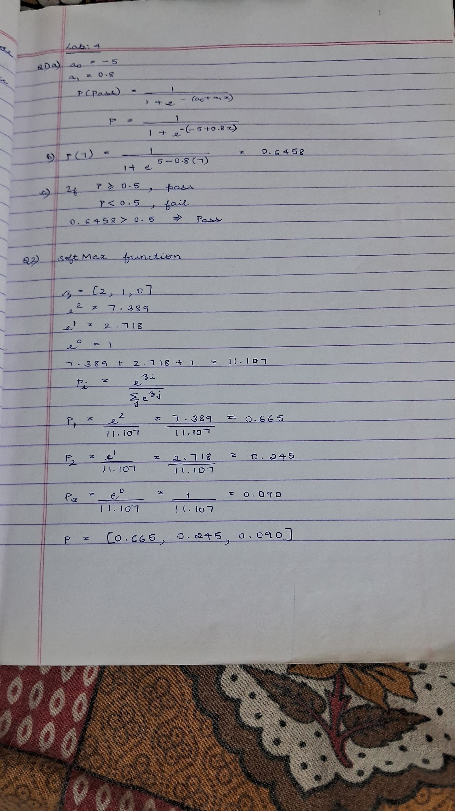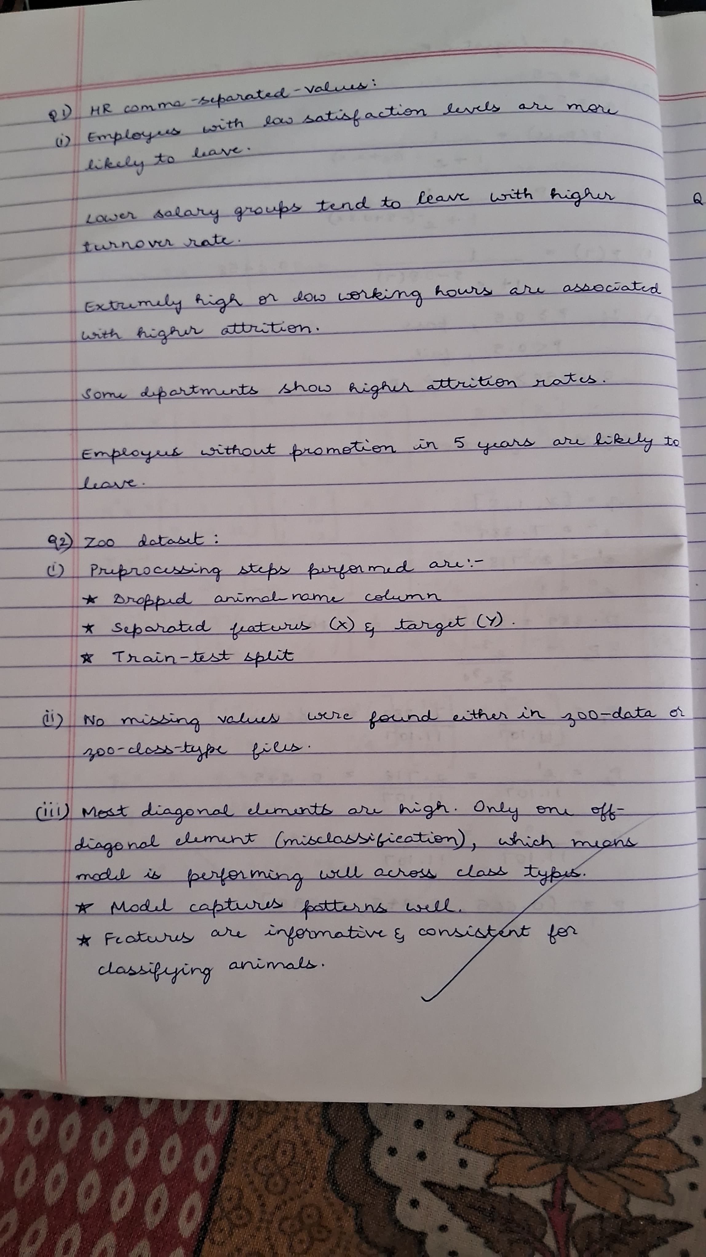

**Code:**

**Logistic_regression_binary**

import pandas as pd

from matplotlib import pyplot as plt

from google.colab import files

# Upload the CSV file

uploaded = files.upload()

df = pd.read_csv(next(iter(uploaded)))  # Load the first uploaded file

print(df.head())

plt.scatter(df.age,df.bought_insurance,marker='+',color='red')

from sklearn.model_selection import train_test_split

X_train, X_test, y_train, y_test = train_test_split(df[['age']],df.bought_insurance,train_size=0.9,random_state=10)

X_train.shape

X_test

from sklearn.linear_model import LogisticRegression

model = LogisticRegression()

model.fit(X_train, y_train)

X_test

y_test

y_predicted = model.predict(X_test)

y_predicted

model.score(X_test,y_test)

model.predict_proba(X_test)

y_predicted = model.predict([[60]])

y_predicted

#model.coef_ indicates value of m in y=m*x + b equation

model.coef_

#model.intercept_ indicates value of b in y=m*x + b equation

model.intercept_

import math

def sigmoid(x):

  return 1 / (1 + math.exp(-x))

def prediction_function(age):

   z = 0.127 * age - 4.973 # 0.12740563 ~ 0.0127 and -4.97335111 ~ -4.97

   y = sigmoid(z)

   return y

age = 35

prediction_function(age)

"""0.37 is less than 0.5 which means person with 35 will not buy the insurance"""

**Logistic_regression_multiclass dataset**

import pandas as pd

from sklearn.datasets import load_iris

from sklearn.model_selection import train_test_split

from sklearn.linear_model import LogisticRegression

from sklearn.metrics import accuracy_score

from sklearn import metrics

import matplotlib.pyplot as plt

from google.colab import files

# Upload the CSV file

uploaded = files.upload()

iris = pd.read_csv(next(iter(uploaded)))

print(iris.head())

X=iris.drop('species',axis='columns')# Features (sepal length, sepal width, petal length, petal width)

y = iris.species # Target labels (0: Setosa, 1: Versicolor, 2: Virginica)

X_train, X_test, y_train, y_test = train_test_split(X, y, test_size=0.2, random_state=42)

# Initialize the Multinomial Logistic Regression model

model = LogisticRegression(multi_class='multinomial')

# Train the model on the training data

model.fit(X_train, y_train)

# Make predictions on the test data

y_pred = model.predict(X_test)

# Calculate the accuracy of the model on the test data

accuracy = accuracy_score(y_test, y_pred)

# Display the accuracy

print(f"Accuracy of the Multinomial Logistic Regression model on the test set: {accuracy:.2f}")

confusion_matrix = metrics.confusion_matrix(y_test, y_pred)

cm_display = metrics.ConfusionMatrixDisplay(confusion_matrix = confusion_matrix, display_labels = ["Setosa", "Versicolor", "Virginica"])

cm_display.plot()

plt.show()

**HR_comma_sep dataset**

import pandas as pd

import matplotlib.pyplot as plt

import seaborn as sns

from sklearn.model_selection import train_test_split

from sklearn.linear_model import LogisticRegression

from sklearn.metrics import accuracy_score, confusion_matrix

from google.colab import files

# Upload the CSV file

uploaded = files.upload()

df = pd.read_csv(next(iter(uploaded)))  # Load the first uploaded file

print(df.head())

# Step 1: Exploratory Data Analysis (EDA)

print("\nMissing Values:\n", df.isnull().sum())

print("\nBasic Statistics:\n", df.describe())

sns.countplot(x='left', data=df)

plt.title('Employee Retention (Left vs Stayed)')

plt.show()

# Step 2: Visualizations to explore relationships with retention

sns.countplot(x='salary', hue='left', data=df)

plt.title('Impact of Salary on Employee Retention')

plt.xlabel('Salary')

plt.ylabel('Count')

plt.show()

sns.countplot(x='Department', hue='left', data=df)

plt.title('Impact of Department on Employee Retention')

plt.xlabel('Department')

plt.ylabel('Count')

plt.xticks(rotation=45)

plt.show()

# Step 3: Correlation Matrix (only for numeric columns)

numeric_df = df.select_dtypes(include=['number'])  # exclude non-numeric columns

corr = numeric_df.corr()

plt.figure(figsize=(10, 6))

sns.heatmap(corr, annot=True, cmap='coolwarm')

plt.title('Correlation Matrix')

plt.show()

# Step 4: Preparing the data for Logistic Regression

df = pd.get_dummies(df, columns=['salary', 'Department'], drop_first=True)

X = df.drop(columns=['left'])

y = df['left']

# Step 5: Split the data into training and testing sets

X_train, X_test, y_train, y_test = train_test_split(X, y, test_size=0.2, random_state=42)

# Step 6: Build the Logistic Regression model

model = LogisticRegression(max_iter=1000)

model.fit(X_train, y_train)

# Step 7: Predicting and Evaluating the Model

y_pred = model.predict(X_test)

accuracy = accuracy_score(y_test, y_pred)

print(f'\nAccuracy of the Logistic Regression Model: {accuracy:.2f}')

cm = confusion_matrix(y_test, y_pred)

plt.figure(figsize=(6, 6))

sns.heatmap(cm, annot=True, fmt='d', cmap='Blues', xticklabels=['Stayed', 'Left'], yticklabels=['Stayed', 'Left'])

plt.title('Confusion Matrix')

plt.xlabel('Predicted')

plt.ylabel('Actual')

plt.show()

##### Program 6

Build KNN Classification model for a given dataset.

**Screenshot**

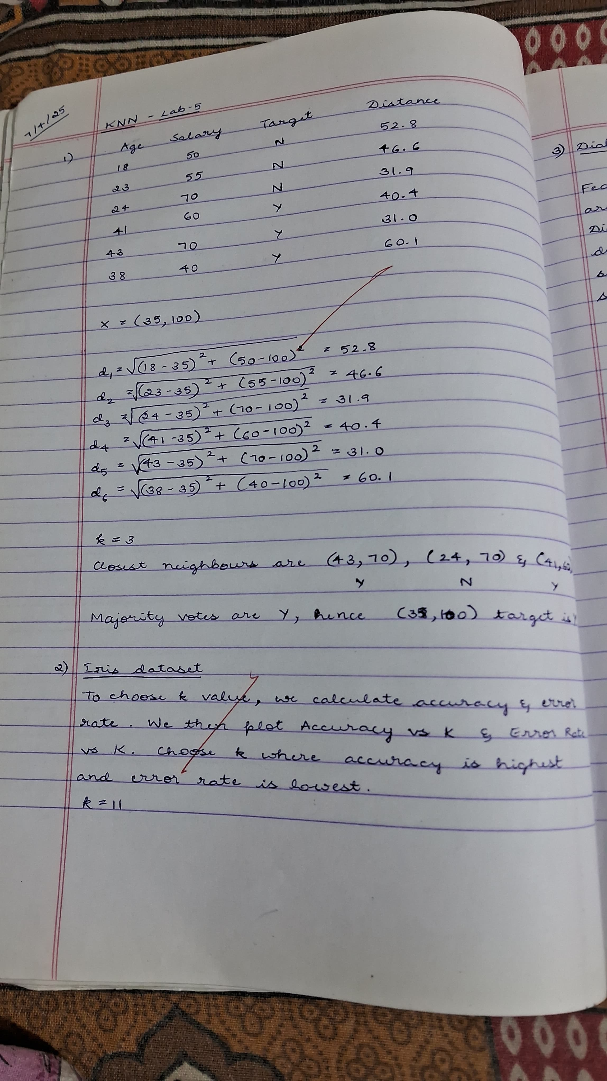



**Code:**

**Iris dataset**

from sklearn.datasets import load_iris

from sklearn.model_selection import train_test_split

from sklearn.neighbors import KNeighborsClassifier

from sklearn.preprocessing import LabelEncoder

from sklearn.metrics import accuracy_score, confusion_matrix, classification_report

import matplotlib.pyplot as plt

import seaborn as sns

import pandas as pd

from google.colab import files

# Upload the CSV file

uploaded = files.upload()

df = pd.read_csv(next(iter(uploaded)))  # Load the first uploaded file

print(df.head())

le = LabelEncoder()

df['species'] = le.fit_transform(df['species'])

# Split features and target

X = df.drop('species', axis=1)

y = df['species']

# Split into train and test sets

X_train, X_test, y_train, y_test = train_test_split(X, y, test_size=0.2, random_state=42)

k = int(math.sqrt(len(X_train)))

if k % 2 == 0:

    k += 1

# Train KNN model

knn = KNeighborsClassifier(n_neighbors=k)

knn.fit(X_train, y_train)

y_pred = knn.predict(X_test)

accuracy = accuracy_score(y_test, y_pred)

conf_matrix = confusion_matrix(y_test, y_pred)

class_report = classification_report(y_test, y_pred, target_names=le.classes_)

print(f"Chosen K: {k}")

print(f"Accuracy Score: {accuracy:.2f}")

print("\nConfusion Matrix:")

print(conf_matrix)

print("\nClassification Report:")

print(class_report)

# Plot confusion matrix

plt.figure(figsize=(6,4))

sns.heatmap(conf_matrix, annot=True, cmap='Blues', fmt='d',

            xticklabels=le.classes_, yticklabels=le.classes_)

plt.xlabel("Predicted")

plt.ylabel("Actual")

plt.title("KNN Confusion Matrix")

plt.tight_layout()

plt.show()

**Diabetes dataset**

import pandas as pd

from sklearn.model_selection import train_test_split

from sklearn.preprocessing import StandardScaler

from sklearn.neighbors import KNeighborsClassifier

from sklearn.metrics import accuracy_score, confusion_matrix

import matplotlib.pyplot as plt

import seaborn as sns

import math

import pandas as pd

from google.colab import files

# Upload the CSV file

uploaded = files.upload()

df = pd.read_csv(next(iter(uploaded)))

print(df.head())

columns = ['Pregnancies', 'Glucose', 'BloodPressure', 'SkinThickness', 'Insulin',

           'BMI', 'DiabetesPedigreeFunction', 'Age', 'Outcome']

# Split features and target

X = df.drop('Outcome', axis=1)

y = df['Outcome']

# Feature Scaling (Standardization)

scaler = StandardScaler()

X_scaled = scaler.fit_transform(X)

# Train-test split (80% train, 20% test)

X_train, X_test, y_train, y_test = train_test_split(X_scaled, y, test_size=0.2, random_state=42)

# Choose k value (sqrt(n) rule of thumb)

k = int(math.sqrt(len(X_train)))

if k % 2 == 0:

    k += 1

# Train the KNN model

knn = KNeighborsClassifier(n_neighbors=k)

knn.fit(X_train, y_train)

y_pred = knn.predict(X_test)

# Evaluate model

accuracy = accuracy_score(y_test, y_pred)

conf_matrix = confusion_matrix(y_test, y_pred)

print(f"Chosen K: {k}")

print(f"Accuracy Score: {accuracy:.2f}")

print("\nConfusion Matrix:")

print(conf_matrix)

plt.figure(figsize=(6, 4))

sns.heatmap(conf_matrix, annot=True, fmt='d', cmap='Blues')

plt.xlabel("Predicted")

plt.ylabel("Actual")

plt.title("KNN Confusion Matrix (Diabetes Dataset)")

plt.tight_layout()

plt.show()

**Heart dataset**

import pandas as pd

import numpy as np

from sklearn.model_selection import train_test_split

from sklearn.preprocessing import StandardScaler

from sklearn.neighbors import KNeighborsClassifier

from sklearn.metrics import accuracy_score, confusion_matrix, classification_report

import matplotlib.pyplot as plt

import seaborn as sns

# Load the dataset

import pandas as pd

from google.colab import files

uploaded = files.upload()

df = pd.read_csv(next(iter(uploaded)))

print(df.head())

# Features and target

X = df.drop('target', axis=1)

y = df['target']

scaler = StandardScaler()

X_scaled = scaler.fit_transform(X)

# Split into training and testing sets

X_train, X_test, y_train, y_test = train_test_split(X_scaled, y, test_size=0.2, random_state=42)

# Find the best K by testing accuracy for multiple values

accuracy_scores = []

k_range = range(1, 31)

for k in k_range:

    knn = KNeighborsClassifier(n_neighbors=k)

    knn.fit(X_train, y_train)

    y_pred = knn.predict(X_test)

    acc = accuracy_score(y_test, y_pred)

    accuracy_scores.append(acc)

# Plot Accuracy vs K

plt.figure(figsize=(10, 5))

plt.plot(k_range, accuracy_scores, marker='o', color='blue')

plt.title('Accuracy vs K value')

plt.xlabel('K')

plt.ylabel('Accuracy')

plt.xticks(k_range)

plt.grid(True)

plt.show()

# Get the best K

best_k = k_range[np.argmax(accuracy_scores)]

print(f"\nBest K value: {best_k} with Accuracy: {max(accuracy_scores):.4f}")

# Retrain model using the best K

best_knn = KNeighborsClassifier(n_neighbors=best_k)

best_knn.fit(X_train, y_train)

y_pred_best = best_knn.predict(X_test)

# Confusion Matrix

conf_matrix = confusion_matrix(y_test, y_pred_best)

plt.figure(figsize=(6, 4))

sns.heatmap(conf_matrix, annot=True, cmap='Blues', fmt='d')

plt.title('Confusion Matrix')

plt.xlabel('Predicted')

plt.ylabel('Actual')

plt.tight_layout()

plt.show()

# Classification Report

report = classification_report(y_test, y_pred_best, target_names=["No Disease", "Disease"])

print("\nClassification Report:")

print(report)

##### Program 7

Build Support vector machine model for a given dataset

**Screenshot**

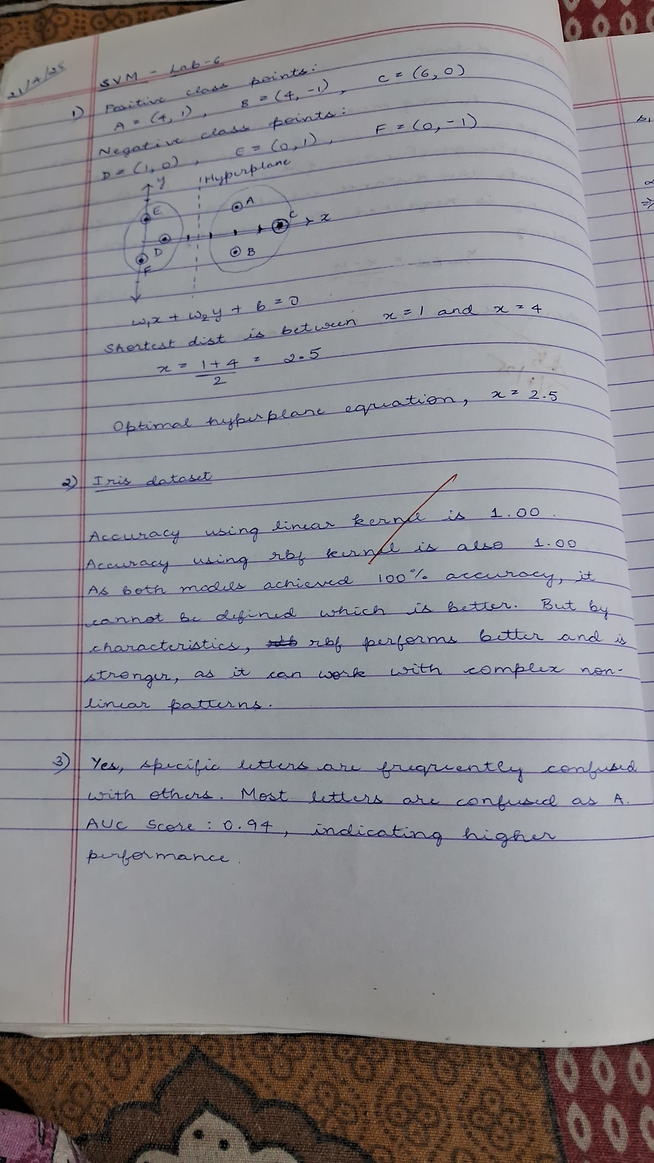

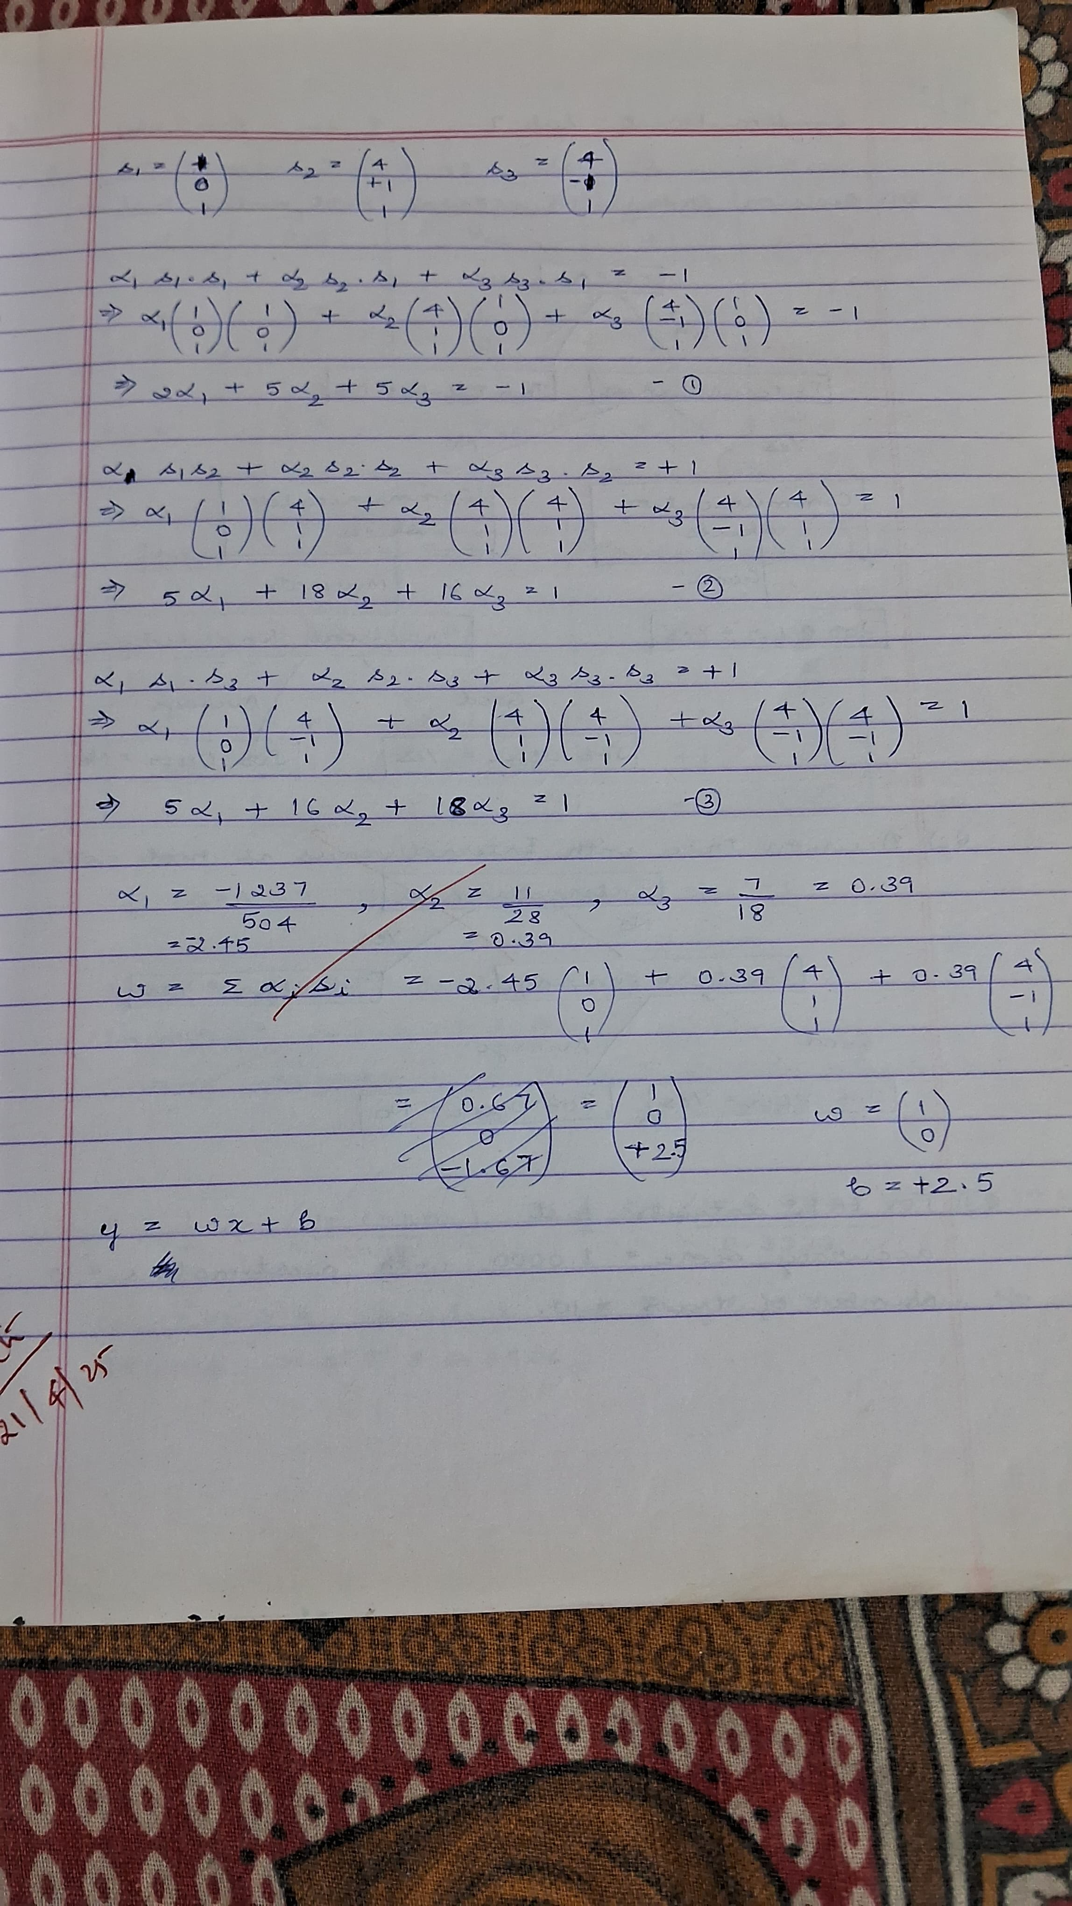

**Code:**

**SVM pynb**

import pandas as pd

from sklearn.datasets import load_digits

digits = load_digits()

digits.target

dir(digits)

digits.target_names

df = pd.DataFrame(digits.data,digits.target)

df.head()

df['target'] = digits.target

df.head(20)

from sklearn.model_selection import train_test_split

X_train, X_test, y_train, y_test = train_test_split(df.drop('target',axis='columns'), df.target, test_size=0.3)

#Using RBF kernel

from sklearn.svm import SVC

rbf_model = SVC(kernel='rbf')

len(X_train)

len(X_test)

rbf_model.fit(X_train, y_train)

rbf_model.score(X_test,y_test)

#Using Linear kernel

linear_model = SVC(kernel='linear')

linear_model.fit(X_train,y_train)

linear_model.score(X_test,y_test)

**Iris dataset**

import pandas as pd

from sklearn.model_selection import train_test_split

from sklearn.svm import SVC

from sklearn.metrics import accuracy_score, confusion_matrix

import matplotlib.pyplot as plt

import seaborn as sns

import tkinter as tk

from tkinter import filedialog

from google.colab import files

# Upload the CSV file

uploaded = files.upload()

iris_df = pd.read_csv(next(iter(uploaded)))

print(iris_df.head())

X = iris_df.drop("species", axis=1)

y = iris_df["species"]

# Split into training and test set (80/20)

X_train, X_test, y_train, y_test = train_test_split(X, y, test_size=0.2, random_state=42)

# Function to train and evaluate an SVM model

def train_evaluate_svm(kernel_type='linear'):

    model = SVC(kernel=kernel_type)

    model.fit(X_train, y_train)

    y_pred = model.predict(X_test)

    acc = accuracy_score(y_test, y_pred)

    cm = confusion_matrix(y_test, y_pred)

    print(f"\n--- SVM with {kernel_type} kernel ---")

    print(f"Accuracy: {acc:.2f}")

    print("Confusion Matrix:")

    print(cm)

    # Plot confusion matrix

    sns.heatmap(cm, annot=True, fmt='d', cmap='Blues', xticklabels=model.classes_, yticklabels=model.classes_)

    plt.title(f'Confusion Matrix ({kernel_type} kernel)')

    plt.xlabel('Predicted')

    plt.ylabel('Actual')

    plt.show()

# Train and evaluate models

train_evaluate_svm(kernel_type='linear')

train_evaluate_svm(kernel_type='rbf')

**Letter-recognition pynb**

import pandas as pd

from sklearn.model_selection import train_test_split

from sklearn.svm import LinearSVC

from sklearn.metrics import accuracy_score, confusion_matrix, roc_auc_score, roc_curve

from sklearn.preprocessing import label_binarize

from sklearn.multiclass import OneVsRestClassifier

import matplotlib.pyplot as plt

import seaborn as sns

import tkinter as tk

from tkinter import filedialog

import numpy as np

from google.colab import files

# Upload the CSV file

uploaded = files.upload()

df = pd.read_csv(next(iter(uploaded)))

print(df.head())

X = df.drop("letter", axis=1)

y = df["letter"]

# Binarize labels for ROC and AUC

classes = sorted(y.unique())

y_bin = label_binarize(y, classes=classes)

# Train-test split

X_train, X_test, y_train, y_test, y_bin_train, y_bin_test = train_test_split(

    X, y, y_bin, test_size=0.2, random_state=42

)

# SVM model (One-vs-Rest for multi-class ROC using LinearSVC)

svm_model = OneVsRestClassifier(LinearSVC())

svm_model.fit(X_train, y_bin_train)

# For predictions:

y_pred_bin = svm_model.predict(X_test)

y_pred_labels = y_pred_bin.argmax(axis=1)

predicted_letters = [classes[i] for i in y_pred_labels]

y_test_labels = y_test.reset_index(drop=True)

accuracy = accuracy_score(y_test_labels, predicted_letters)

print(f"\nAccuracy Score: {accuracy:.2f}")

# Confusion Matrix

cm = confusion_matrix(y_test_labels, predicted_letters, labels=classes)

plt.figure(figsize=(12, 10))

sns.heatmap(cm, annot=False, cmap="Blues", xticklabels=classes, yticklabels=classes)

plt.title("Confusion Matrix")

plt.xlabel("Predicted")

plt.ylabel("Actual")

plt.show()

# ROC Curve & AUC Score using decision_function

y_score = svm_model.decision_function(X_test)

fpr = dict()

tpr = dict()

roc_auc = dict()

for i in range(len(classes)):

    fpr[i], tpr[i], _ = roc_curve(y_bin_test[:, i], y_score[:, i])

    roc_auc[i] = roc_auc_score(y_bin_test[:, i], y_score[:, i])

# Plot ROC for a few classes (First 5 for simplicity)

plt.figure(figsize=(10, 8))

for i in range(5):  # show first 5 classes for simplicity

    plt.plot(fpr[i], tpr[i], label=f'Class {classes[i]} (AUC = {roc_auc[i]:.2f})')

plt.plot([0, 1], [0, 1], 'k--')

plt.title("ROC Curve (First 5 Classes)")

plt.xlabel("False Positive Rate")

plt.ylabel("True Positive Rate")

plt.legend(loc="lower right")

plt.grid()

plt.show()

mean_auc = np.mean(list(roc_auc.values()))

print(f"Average AUC Score (macro-average over classes): {mean_auc:.2f}")

##### Program 8

Implement Random forest ensemble method on a given dataset.

**Screenshot**

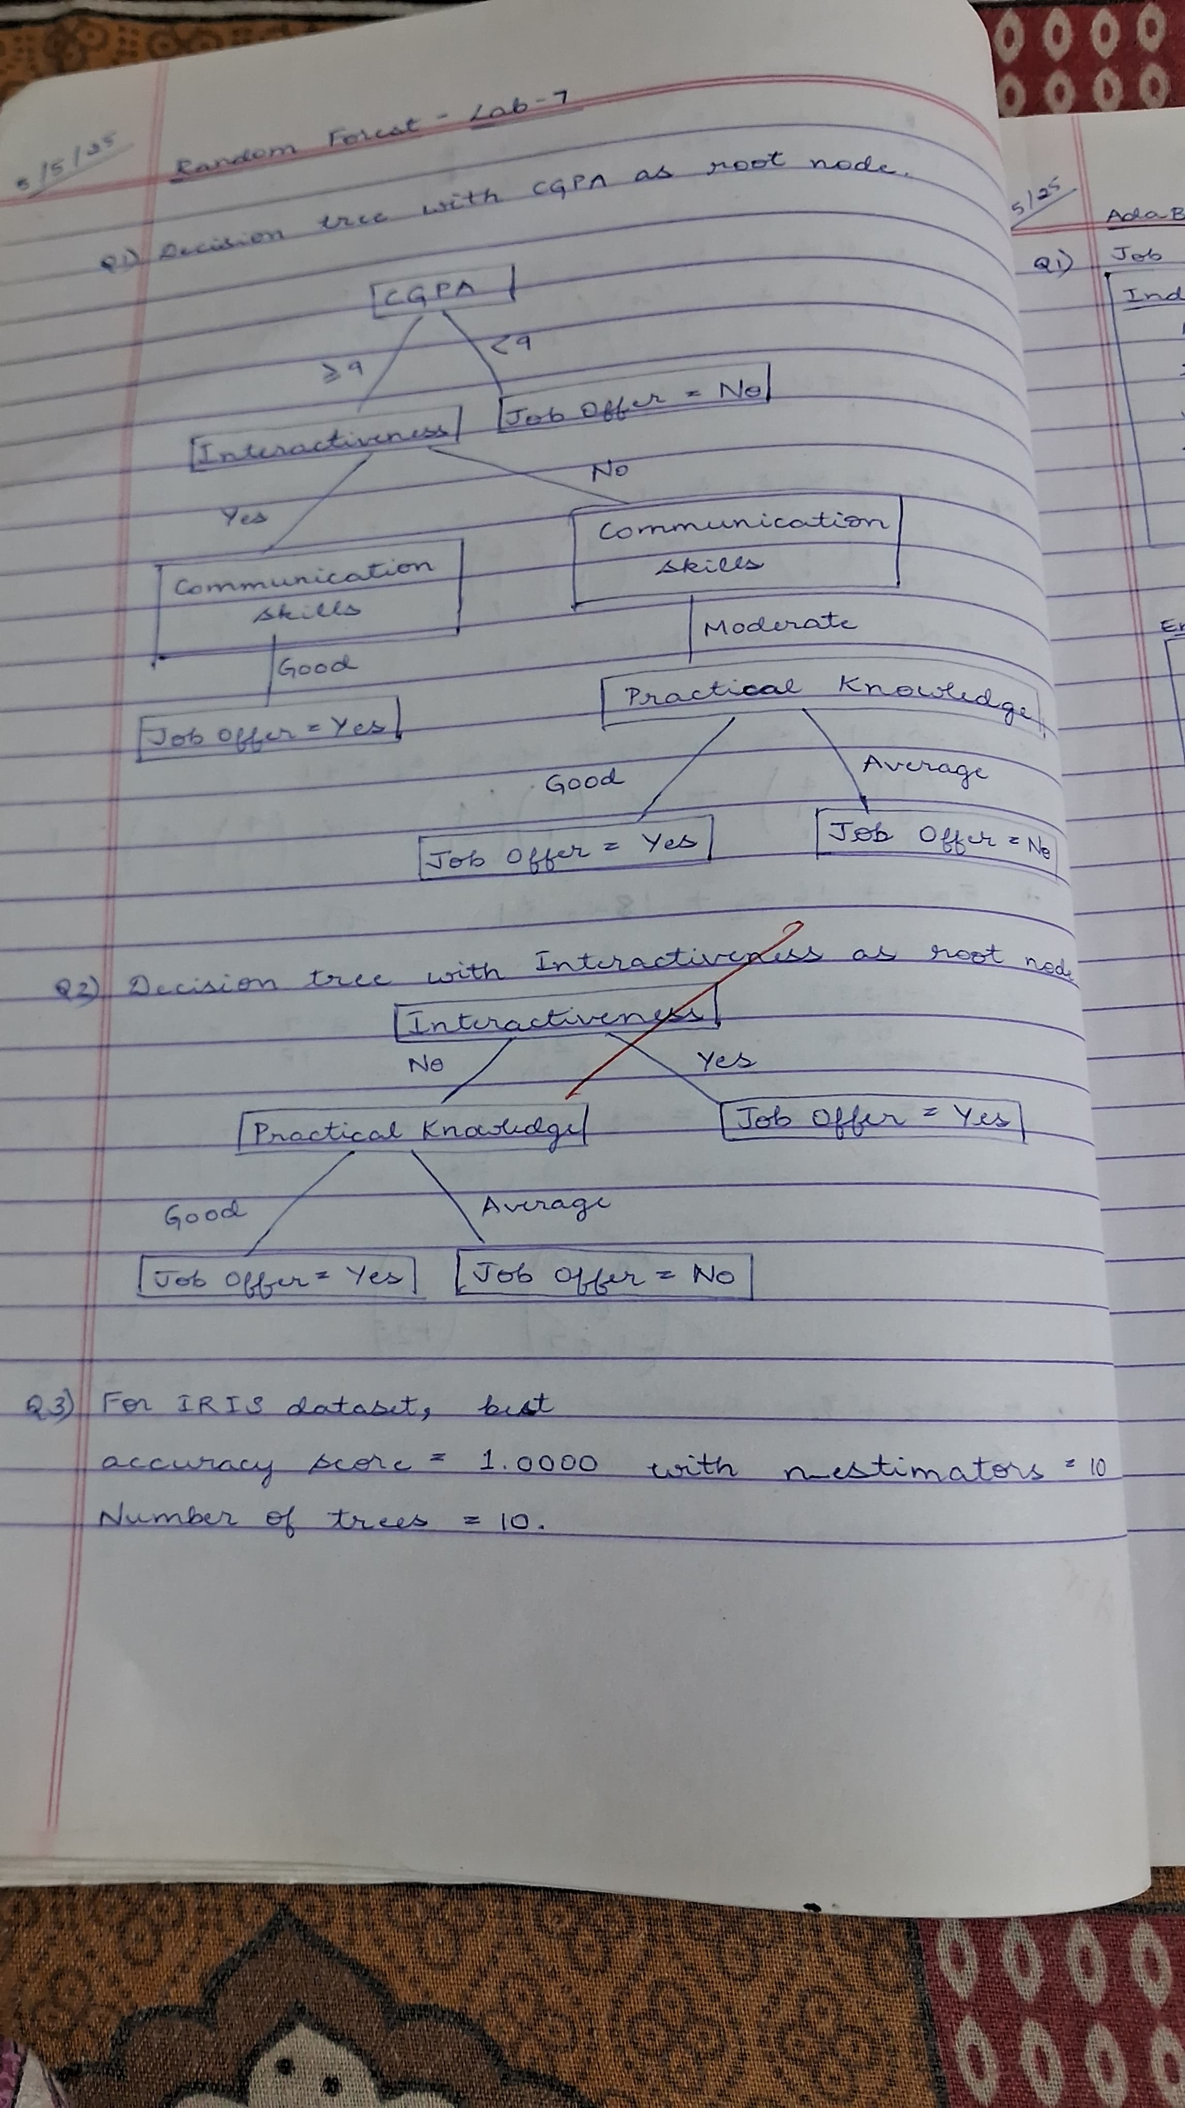

**Code:**

**Iris dataset**

import pandas as pd

from sklearn.model_selection import train_test_split

from sklearn.ensemble import RandomForestClassifier

from sklearn.metrics import accuracy_score

import matplotlib.pyplot as plt

from google.colab import files

# Upload the CSV file

uploaded = files.upload()

df = pd.read_csv(next(iter(uploaded)))

print(df.head())

# Split data into features and target

X = df.drop("species", axis=1)

y = df["species"]

# Split into train and test sets

X_train, X_test, y_train, y_test = train_test_split(X, y, test_size=0.2, random_state=42)

# 1. Train model with default n_estimators = 10

rf_default = RandomForestClassifier(random_state=42)

rf_default.fit(X_train, y_train)

y_pred_default = rf_default.predict(X_test)

default_score = accuracy_score(y_test, y_pred_default)

print(f"Accuracy with default n_estimators=10: {default_score:.4f}")

# 2. Fine-tuning: test different values for n_estimators

scores = {}

for n in range(5, 105, 5):  # from 5 to 100 in steps of 5

    rf = RandomForestClassifier(n_estimators=n, random_state=42)

    rf.fit(X_train, y_train)

    y_pred = rf.predict(X_test)

    acc = accuracy_score(y_test, y_pred)

    scores[n] = acc

# Find best score and corresponding n_estimators

best_n = max(scores, key=scores.get)

best_score = scores[best_n]

print(f"Best accuracy: {best_score:.4f} with n_estimators={best_n}")

# Optional: plot accuracy vs. number of trees

plt.plot(list(scores.keys()), list(scores.values()), marker='o')

plt.xlabel("Number of Trees (n_estimators)")

plt.ylabel("Accuracy")

plt.title("Random Forest Accuracy vs. Number of Trees")

plt.grid(True)

plt.show()

##### Program 9

Implement Boosting ensemble method on a given dataset**.**

**Screenshot**

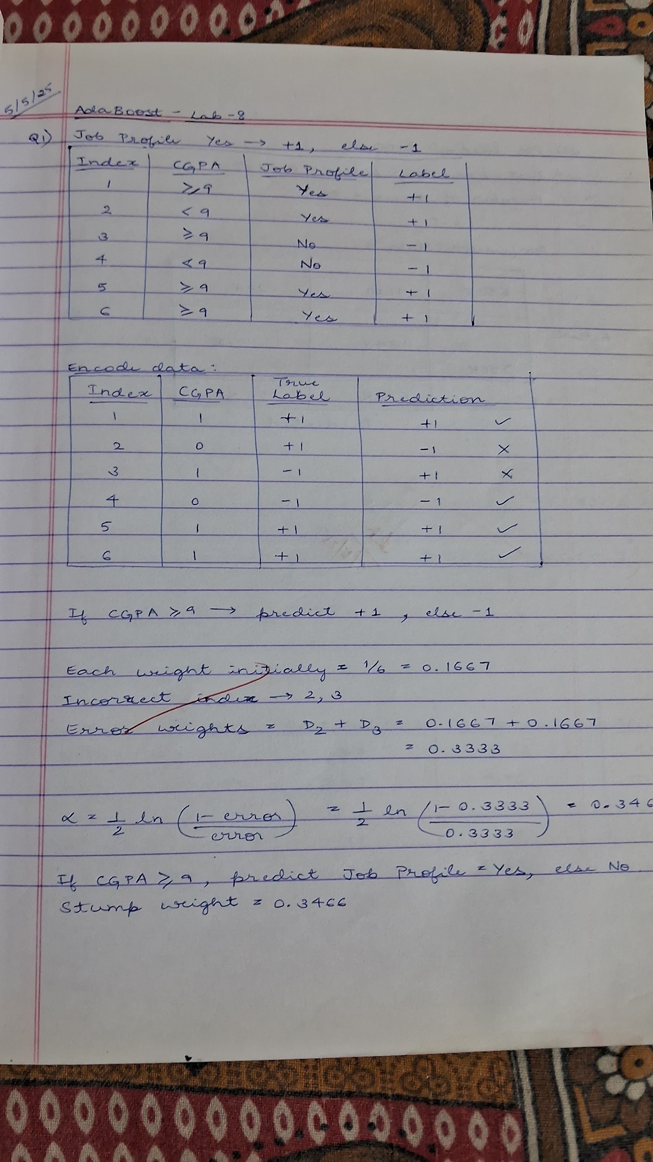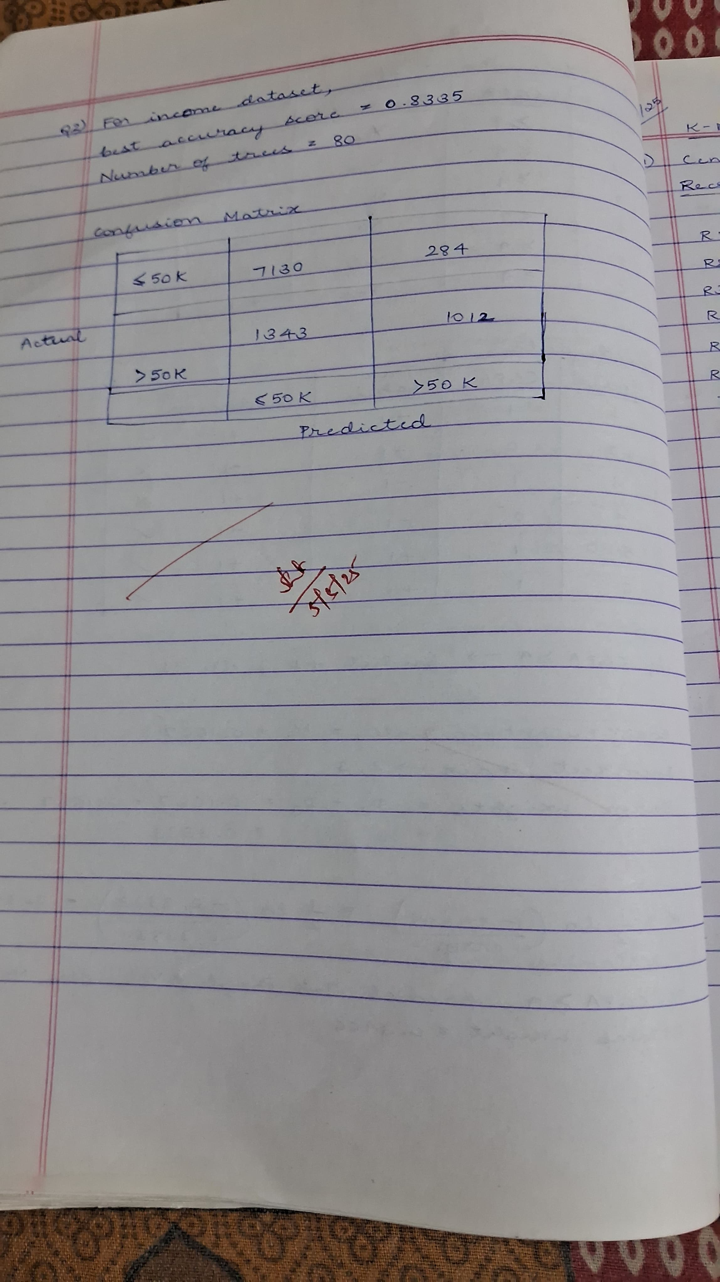

**Code:**

**Income dataset**

import pandas as pd

from sklearn.model_selection import train_test_split

from sklearn.ensemble import AdaBoostClassifier

from sklearn.tree import DecisionTreeClassifier

from sklearn.metrics import accuracy_score

import matplotlib.pyplot as plt

from google.colab import files

# Upload the CSV file

uploaded = files.upload()

df = pd.read_csv(next(iter(uploaded)))

print(df.head())

# Split features and target

X = df.drop("income_level", axis=1)

y = df["income_level"]

# Encode target if necessary (e.g., if it's strings)

y = y.astype('category').cat.codes

# Train-test split

X_train, X_test, y_train, y_test = train_test_split(X, y, test_size=0.2, random_state=42)

# 1. Train AdaBoost with default n_estimators = 10

ada_default = AdaBoostClassifier(

    estimator=DecisionTreeClassifier(max_depth=1),

    n_estimators=10,

    random_state=42

)

ada_default.fit(X_train, y_train)

y_pred_default = ada_default.predict(X_test)

default_score = accuracy_score(y_test, y_pred_default)

print(f"Accuracy with default n_estimators=10: {default_score:.4f}")

# 2. Fine-tune n_estimators

scores = {}

for n in range(10, 110, 10):  # Try 10 to 100 in steps of 10

    ada = AdaBoostClassifier(

        estimator=DecisionTreeClassifier(max_depth=1),

        n_estimators=n,

        random_state=42

    )

    ada.fit(X_train, y_train)

    y_pred = ada.predict(X_test)

    acc = accuracy_score(y_test, y_pred)

    scores[n] = acc

# Find best score and corresponding number of estimators

best_n = max(scores, key=scores.get)

best_score = scores[best_n]

print(f"Best accuracy: {best_score:.4f} with n_estimators={best_n}")

# Plot

plt.plot(list(scores.keys()), list(scores.values()), marker='o')

plt.xlabel("Number of Trees (n_estimators)")

plt.ylabel("Accuracy")

plt.title("AdaBoost Accuracy vs. Number of Trees")

plt.grid(True)

plt.show()

##### Program 10

Build k-Means algorithm to cluster a set of data stored in a .CSV file.

**Screenshot**

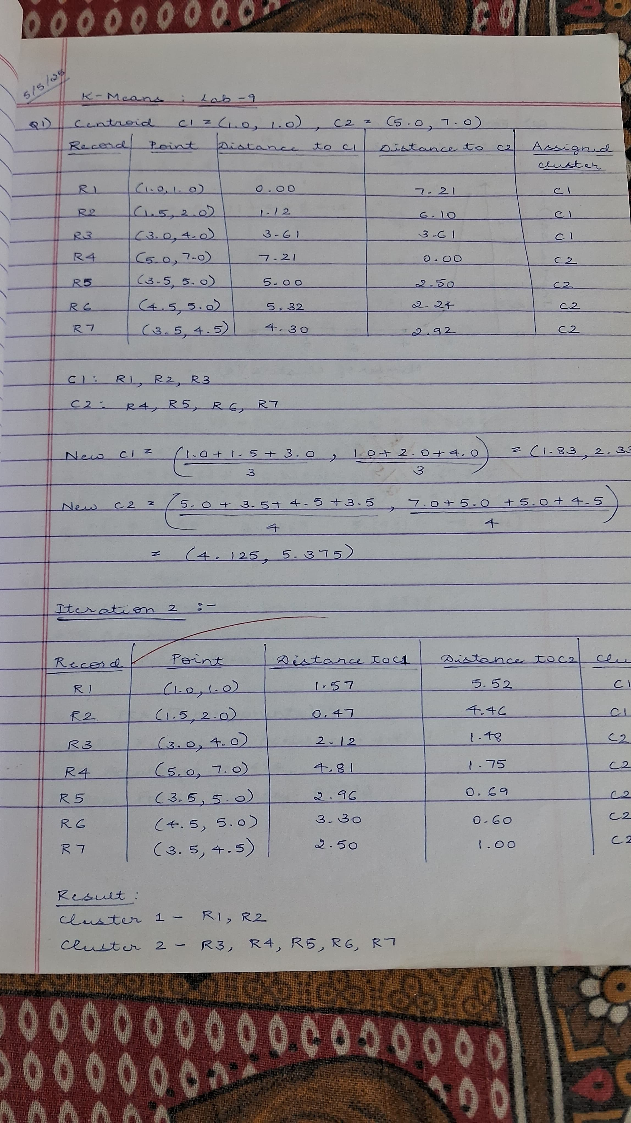

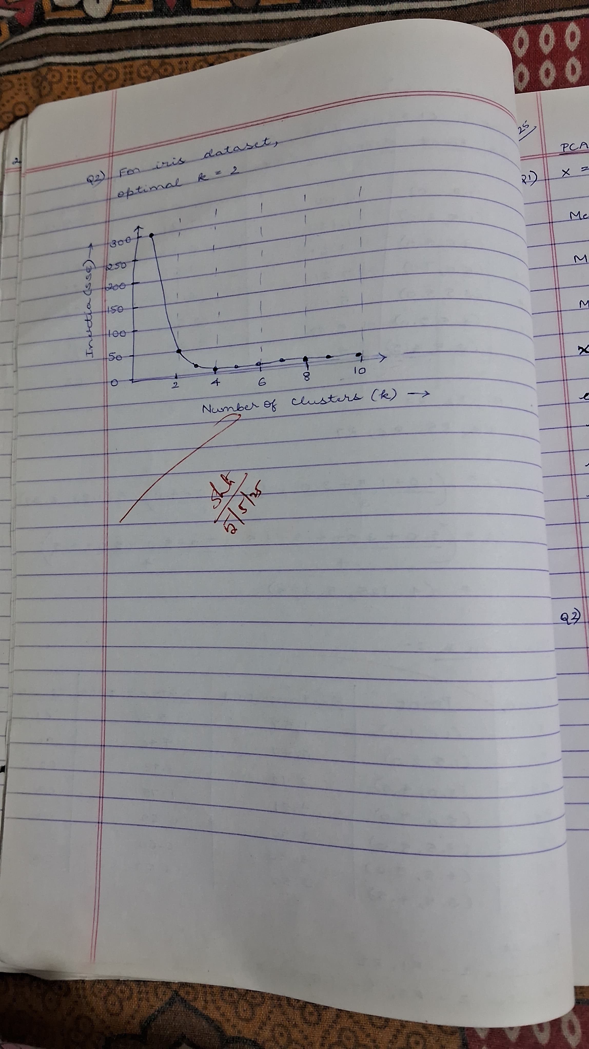

**Code:**

**Iris dataset**

import pandas as pd

import matplotlib.pyplot as plt

from sklearn.cluster import KMeans

from sklearn.preprocessing import StandardScaler

from google.colab import files

# Upload the CSV file

uploaded = files.upload()

# Read the CSV file into a pandas DataFrame

df = pd.read_csv(next(iter(uploaded)))  # Load the first uploaded file

print(df.head())

# Step 2: Use only petal length and petal width

X = df[['petal_length', 'petal_width']]

# Step 3: Scale the features

scaler = StandardScaler()

X_scaled = scaler.fit_transform(X)

# Step 4: Elbow Method to find optimal k

inertia = []

k_range = range(1, 11)

for k in k_range:

    kmeans = KMeans(n_clusters=k, random_state=42, n_init='auto')

    kmeans.fit(X_scaled)

    inertia.append(kmeans.inertia_)  # Sum of squared distances to cluster centers

# Step 5: Plot elbow curve

plt.figure(figsize=(8, 4))

plt.plot(k_range, inertia, 'bo-')

plt.xlabel('Number of Clusters (k)')

plt.ylabel('Inertia (SSE)')

plt.title('Elbow Method For Optimal k')

plt.grid(True)

plt.show()

##### Program 11

Implement Dimensionality reduction using Principal Component Analysis (PCA) method.

**Screenshot**

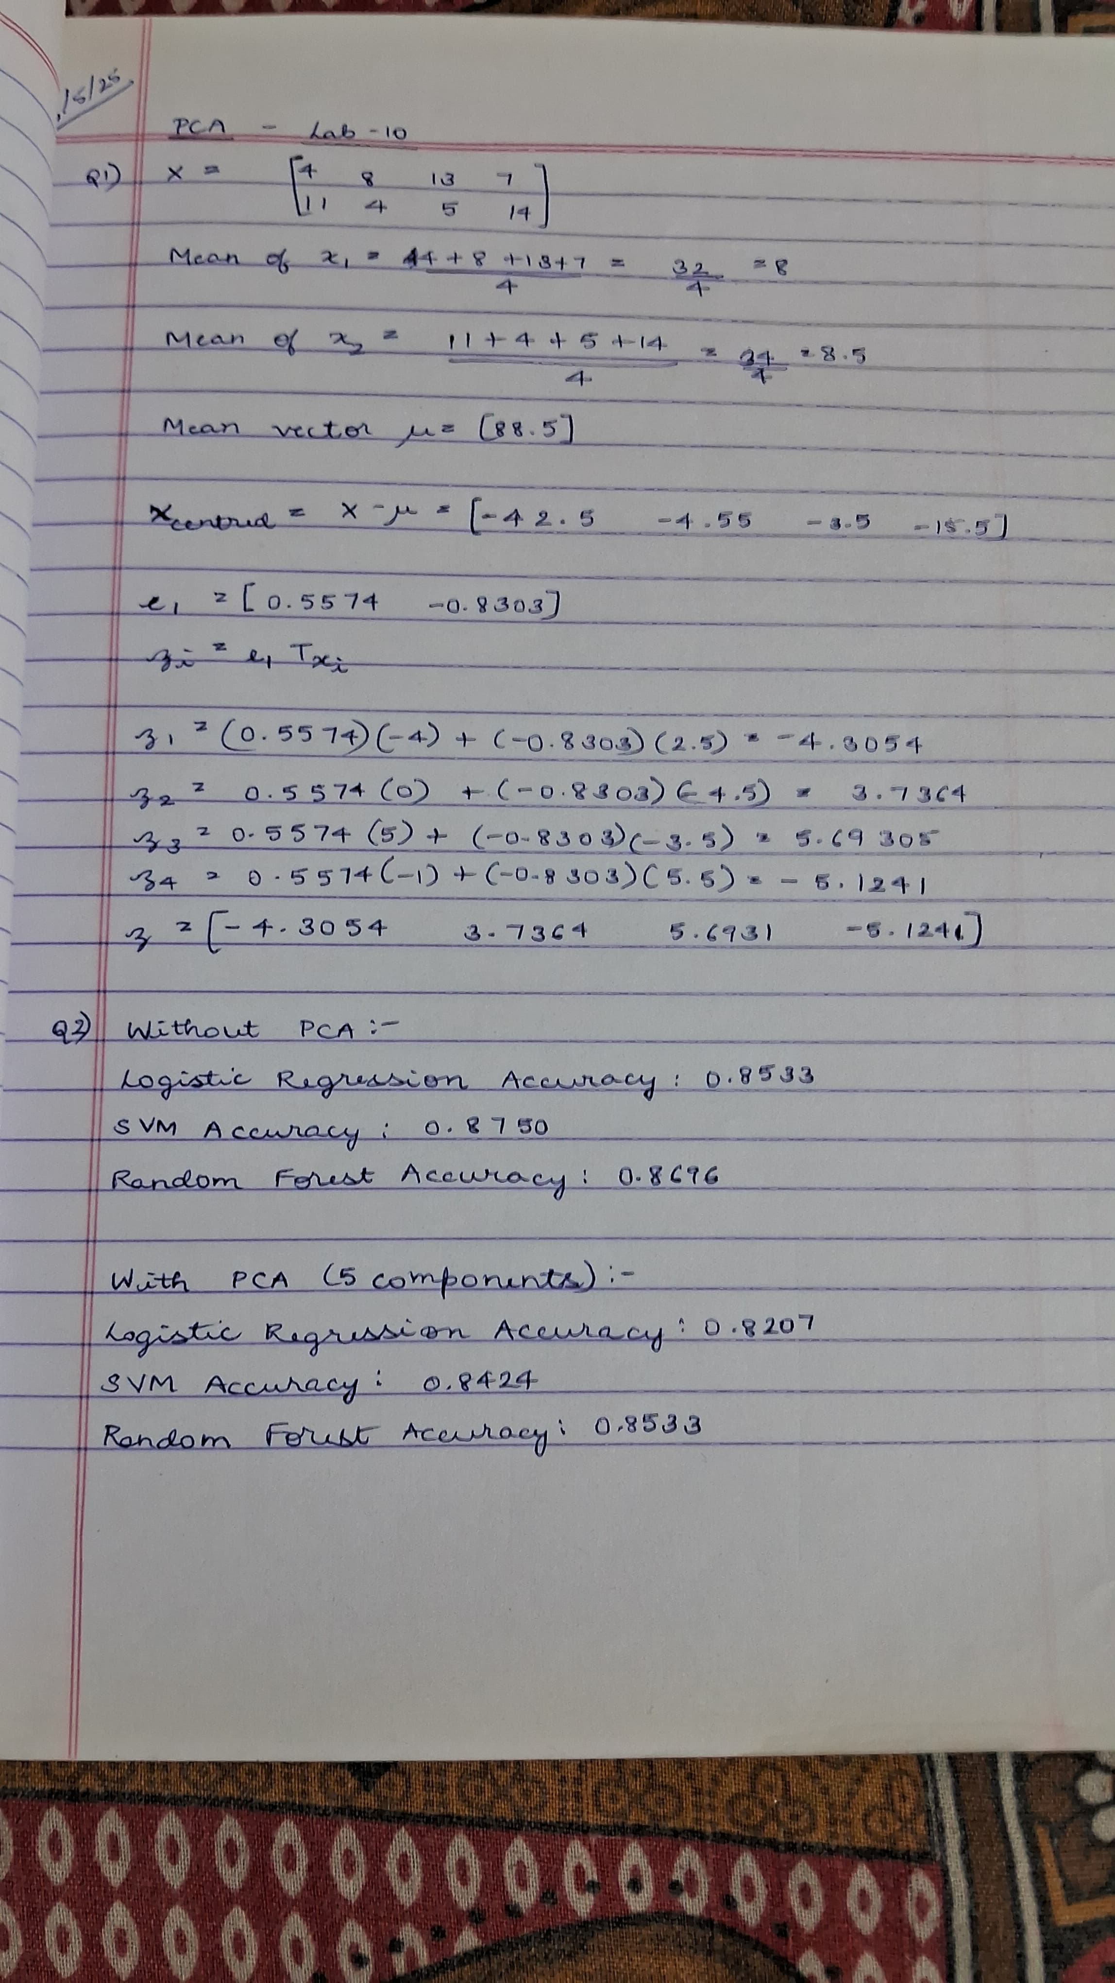

**Code:**

**Heart dataset**

import pandas as pd

from sklearn.preprocessing import LabelEncoder, StandardScaler

from sklearn.model_selection import train_test_split

from sklearn.linear_model import LogisticRegression

from sklearn.svm import SVC

from sklearn.ensemble import RandomForestClassifier

from sklearn.metrics import accuracy_score

from sklearn.decomposition import PCA

from google.colab import files

# Upload the CSV file

uploaded = files.upload()

df = pd.read_csv(next(iter(uploaded)))

print(df.head())

# 2. Encode categorical columns

label_enc_cols = ['Sex', 'ExerciseAngina']

for col in label_enc_cols:

    le = LabelEncoder()

    df[col] = le.fit_transform(df[col])

# One-hot encode nominal categorical columns

df = pd.get_dummies(df, columns=['ChestPainType', 'RestingECG', 'ST_Slope'], drop_first=True)

# 3. Split features and target

X = df.drop('HeartDisease', axis=1)

y = df['HeartDisease']

# 4. Scale features

scaler = StandardScaler()

X_scaled = scaler.fit_transform(X)

# 5. Train-Test Split

X_train, X_test, y_train, y_test = train_test_split(X_scaled, y, test_size=0.2, random_state=42)

# 6. Train classifiers and evaluate

models = {

    'Logistic Regression': LogisticRegression(),

    'SVM': SVC(),

    'Random Forest': RandomForestClassifier()

}

print("Without PCA:")

for name, model in models.items():

    model.fit(X_train, y_train)

    preds = model.predict(X_test)

    acc = accuracy_score(y_test, preds)

    print(f"{name} Accuracy: {acc:.4f}")

# 7. Apply PCA

pca = PCA(n_components=5)  # Try fewer components for dimensionality reduction

X_pca = pca.fit_transform(X_scaled)

X_train_pca, X_test_pca, y_train, y_test = train_test_split(X_pca, y, test_size=0.2, random_state=42)

print("\nWith PCA (5 components):")

for name, model in models.items():

    model.fit(X_train_pca, y_train)

    preds = model.predict(X_test_pca)

    acc = accuracy_score(y_test, preds)

    print(f"{name} Accuracy: {acc:.4f}")